**New Zealand Diploma in Information Systems**

**HTCS5607 IS Application Project**

**TECHNICAL REPORT TEMPLATE**

**Project Name: Saint Albert hospital**

|  |  |  |  |
| --- | --- | --- | --- |
| **Project Team Name(s)** | **Student ID** | **Email** | **Phone** |
| ***Project Manager***  *[Mohsen M Ansari]* | 1551891 | moalem01@myunitec.ac.nz | 02102424107 |
| ***Deputy Project Manager***  *[Name]* |  |  |  |
| ***Team Members***  *[Name (s)]* |  |  |  |

**Client Stakeholders**

|  |  |  |
| --- | --- | --- |
| **Client Stakeholders** | **Full name and title** | **Contact details** |
| **Project Sponsor(s)** | *Lei Song*  *Simon Dacey* | *[lsong@unitec.ac.nz]*  *[sdacey@unitec.ac.nz]* |

**DATE OF SUBMISSION**

*25/11/2021*

Table of Contents

1. Document Control 4

1.1 Version History 4

1.2 Contribution to Report sections 4

1.3 Glossary 4

2. Executive Summary 5

3. Introduction 6

4. Technology Review 7

5. IT Methodology 8

6. Project Management 11

6.1 Project Management Narrative 11

6.2 Project Plan with Milestones 11

6.3 Project Governance Responsibilities 12

6.4 Project Meetings 12

6.5 Project Reports 12

6.6 Project Risk and Issue Analysis 13

7. Requirements Analysis 14

7.1 Introduction 14

7.2 Use Case Diagram 15

7.3 Business Use Case Narratives (Descriptions) 16

7.4 Activity Diagrams 17

7.5 Overall Class Diagram 32

8. Project Design 33

8.1 Introduction 33

8.2 Software List 34

8.3 Version Control Software 34

8.4 Design Use Case Narratives (Descriptions) 35

8.5 Sequence Diagrams 43

8.6 Deployment Diagram 51

8.7 Database Design 52

8.8 Annotated User Interface Designs 52

8.9 Test Plan 60

9. Project Training 61

9.1 End User Background and Training Objectives 61

9.2 Training Materials 61

9.3 Training Deliverables 61

9.4 Evaluation 61

10. Conclusion & Lessons Learned 62

References 64

Appendices 65

# 1. Document Control

## 1.1 Version History

This document has had the following revisions:

| **Version** | **Date** | **Author** | **Description of Change** |
| --- | --- | --- | --- |
| 0.1 | 25 Nov 2021 | Mohsen M Ansari | Initial draft |

## 1.2 Contribution to Report sections

| **Project Team Member name** | **Student ID** | **Report Section** |
| --- | --- | --- |
|  |  |  |
|  |  |  |
|  |  |  |
|  |  |  |

## 1.3 Glossary

To provide clarity, terms and acronyms used in this document are defined as follows:

| **Term / Abbreviation** | **Definition** |
| --- | --- |
| Supervisor | Technical Advisor |
|  |  |
|  |  |

# 2. Executive Summary

This project reviewed requirements set out by stakeholders to plan and ultimately provide solutions for the needs of a hospital, Saint Albert Hospital in Auckland.

After thorough requirements collection and analyses, project sponsors sent a draft to the project manager. A detailed GANTT chart was created outlining the milestones and the start and end date of each stage, with regular records of progress.

Analysis of the requirements led to the creation of 8 business use cases to address the expectations of the product. These are for:

* Adding/Updating/Deleting Medication
* Adding/Updating/Deleting Ward
* Producing Wards Report
* and Closing Admission

The product will meet the expectations of the clients and perform tasks to add/update/delete medication and add/update/delete ward, in addition to providing report of the wards showing the patients details admitted to those wards and also the function of closing any admission. The data will be written and saved onto the designed MS Access database.

# 3. Introduction

Saint Albert Hospital in Auckland has commissioned for a database application which can replace the current ad-hoc paper-based system being flagged as not efficient leading to problems with doctors’ fees and medication costs and so on. The surge in the number of patients using the hospital services called for a change to a robust system to keep tracks of medications, wards and admissions and to prevent data loss.

This project report details the specifics of the tasks involved to create a database application to manage a hospital’s data. Information such as medications, admissions and wards will be managed using the application in an efficient way and with ease. The administrators can add medications and wards to the database and will be able to update and delete medications and wards. The report of the wards can be generated with a click of a mouse and the administrators can also close admission upon releasing a patient from the hospital.

The project commenced with a detail analysis of the requirements collected from the stakeholders and with close communication with the project sponsors.

# 4. Technology Review

The database application was developed using MS Access and C#. Similar applications can be developed using other database applications such as MySQL, ORACLE or SQL SERVER. For the development of the forms, other IDEs such as PyCharm, Eclipse or PhpStorm.

Caspio (2020) is a no-code platform for building online database applications without having to write code. It has designed an eHospital application for out-patient management, inpatient billing, discharge summary, laboratory management, pharmacy management, payroll and HR and finance management. SoftClinic (2021) empowers hospitals with services across various medical spectrum such as Ophthalmology, Orthopaedic, Paediatric, General Surgery, Neurology and Cardiology. . NextGenHMS (2021) provides cloud-based application for Android, IOS, MAC and Windows systems and for many medical sections such as dental, ambulatory and behavioural health.

Saint Albert Hospital application provides various services for patients’ admissions and payment records, as well as doctors’ allocation to patients and medical research topics and projects. Patients’ prescription and medication can also be managed by this application. It also produces reports for wards, patients, admissions and research projects as well as printing invoice. Creating various reports for different elements is a strong feature of this application. Also, user-friendly design of the interface make this application pleasant for novice users of online health management products.

# 5. IT Methodology

Two main IT methodology could be considered for the management of this project. One was the Waterfall Model, and second Agile.

Waterfall model is a ‘linear-sequential’ life cycle model in which each phase of the project must be completed before the next phase begins. “In this model the phases do not overlap” (Tutorialspoint, 2021a), and there is a sequential development in the design of the software.

As shown in the diagram below, there are six steps similar and corresponding to the steps in SDLC:

* *Requirement gathering and analysis*: detailed requirements of the software system are gathered. Requirements and expectations are established.
* *System Design*: the requirements established in the first phase are studied. Overall system architecture and hardware requirements are defined.
* *Implementation*: the software is built using codes. Units are developed and prepared for testing.
* *Integration and Testing*: all the units developed in the *Implementation* stage are integrated into a system and tested.
* *Deployment*: the product is deployed in the respective customer environment.
* *Maintenance*: as per client’s request, errors are fixed, changes and patches are released. (Guru, 2021; Tutorialspoint, 2021a)

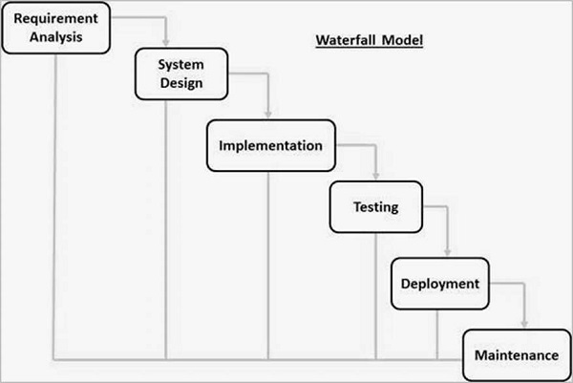

*Retrieved from* [*https://www.tutorialspoint.com/sdlc/sdlc_waterfall_model.htm*](https://www.tutorialspoint.com/sdlc/sdlc_waterfall_model.htm)

In this model, the requirement analysis proves to be of paramount importance as there will be no communication with the client during the product design. Once the product is ready and is handed to the client, feedback on the functionality of product’s features and possible defects must be communicated with the design team and modifications should follow in order to alleviate issues with the software.

“Apart from the V-Model, there are iterative development models, where development is carried out in phases, with each phase adding a functionality to the software. Each phase comprises its independent set of development and testing activities.” (Guru99, 2021a). One good example of development lifecycle following iterative method is Agile Development.

Testing needs to be done at every stage of the development process, from requirement analysis to deployment. The iterative development models such as Agile aims to achieve this. Both development and testing activities are concurrent (Guru99, 2021b). Agile testing methodology is not sequential as in Waterfall Approach, but continuous. This approach “promotes continuous interaction of development and testing during SDLC process of any project.” (Guru99, 2021c). It is also customer-oriented in a way that customers have early and frequent opportunities to look at the product and make decision and changes to the project as opposed to the Waterfall method where the customer can only see the product at the end of the project. “Agile encourages flexible response to change.” (Guru99, 2021b)

Agile Method breaks the entire product into smaller incremental iterations. The project scope and requirements are laid down at the beginning of the development process. Every iteration involves cross functional teams working simultaneously on different areas of the project such as:

* Planning
* Requirement gathering and analysis
* Design
* Coding/Construction
* Testing/Quality Assurance
* Deployment
* Feedback

(Tutorialspoint, 2021b)

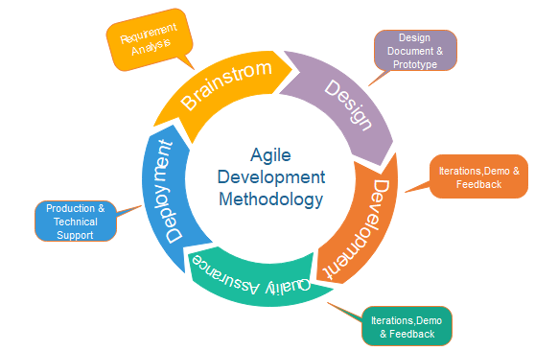

*Retrieved from https://www.javatpoint.com/software-engineering-agile-model*

# 6. Project Management

## 6.1 Project Management Narrative

The development of the project was in stages, from drafting business use cases, to drawing diagrams and coding and each step was required in order to commence the next step of the project. This project, hence, followed the Waterfall systems development lifecycle (as explained in detail in part 5. IT Methodology section above), where first the requirements were collected and studied, class diagram was drawn to define what classes are involved and what attributes are needed together with the relationship between those classes. Business-level use cases were drafted and 8 activity diagrams would supplement this analysis.

The next stage was the Design stage, where design-level use cases were drafted and the data base was created using the data dictionary. Interface wireframes were created to provide an overview of what the final application would look like. Test plans were also drafted in close observation of the steps listed in the use cases.

## 6.2 Project Plan with Milestones

|  |  |  |
| --- | --- | --- |
| **Stage** | **Activity** | **Dates** |
| **1** | **Information gathering** |  |
| 1.1 | Analyse project requirement | 20 – 21 Sep |
| 1.2 | Study use cases | 20 – 21 Sep |
| 1.3 | Draft business use case narratives (descriptors) | 23 – 27 Sep |
| 1.4 | Draw use case diagram | 28 Sep |
| 1.5 | Draw activity diagrams and class diagram | 28 Sep – 1 Oct |
| **2** | **Project design** |  |
| 2.1 | Version control | 6 Oct |
| 2.2 | Draft use case narratives (descriptors) | 7 Oct – 10 Oct |
| 2.3 | Draw sequence diagrams | 11 Oct – 12 Oct |
| 2.4 | Draw deployment diagram with descriptors | 13 Oct |
| 2.5 | Data dictionary & database design | 13 Oct – 13 Oct |
| 2.6 | Annotated interface designs | 14 Oct – 18 Oct |
| 2.7 | Test plans | 19 Oct – 20 Oct |
| **3** | **Implementation and testing** |  |
| 3.1 | Coding | 21 Oct – 10 Nov |
| 3.2 | Test application | 11 Nov |
| **4** | **User Training** | 12 Nov – 14 Nov |
| **5** | **Technical Report** | 15 Nov – 18 Nov |

## 6.3 Project Governance Responsibilities

Project Manager, Mohsen M. Ansari and Project Sponsors, Lei song and Simon Dacey were responsible for the project management and quality assurance. The parties involved discussed the draw of a detailed plan in GANTT chart for the management of the project and had regular weekly meetings to check project development and milestones. A bi-weekly report was sent to the project sponsors, detailing work achieved and issues encountered.

## 6.4 Project Meetings

|  |  |  |  |  |
| --- | --- | --- | --- | --- |
| **Meeting** | **Date** | **Duration** | **Participants** | **Type** |
| 1 | 30/09/2021 | 15 minutes | Simon Dacey and Mohsen M Ansari | Online |
| 2 | 20/10/2021 | 15 Minutes | Lei Song and Mohsen M Ansari | Online |
| 3 | 27/10/2021 | 15 minutes | Simon Dacey and Mohsen M Ansari | Online |
| 4 | 03/11/2021 | 15 minutes | Lei Song and Mohsen M Ansari | Online |
| 5 | 11/11/2021 | 15 minutes | Simon Dacey and Mohsen M Ansari | Online |
| 6 | 18/11/2021 | 15 minutes | Lei Song and Mohsen M Ansari | Online |

## 

## 6.5 Project Reports

Three project status reports were drafted and submitted on weeks 3, 5 and 7. The aim of these reports was to outline the developmental stages of the project and to present a summary of the progress, also highlighting any unachieved milestones. Risks and issues were also pointed out.

The first status reported all areas to meet expectations and highlighted the issue of working with a device which does not support certain required soft wares. The alternative was to use Virtual Machine (VM) which alleviated the problem to great extent, however the speed of delivery was affected due to the limitations inherent in the VM application. Also, communicated with the project sponsors the reason for postponing the draft of technical review.

The second status report indicated expected deliverable milestones to be in good progress. Plans for the next and last status report, which were to complete project development material, were outlined.

The third and last status report also summarised that the progress of work is matched with the expected timeframe. No issues were reported and scheduled plans for next period were set to be creating end user training material and completing project’s technical report.

## 6.6 Project Risk and Issue Analysis

Three risk factors were anticipated that could potentially affect the project’s progress. These were listed as :

* seasonal cold/flue
* internet issues and
* computer breakdown

These risks were evaluated on the basis of their likelihood and the consequences they can weigh on the project.

No issues were reported except for the use of Virtual Machine which was highlighted in the project reports.

# 7. Requirements Analysis

## 7.1 Introduction

The project requirements were closely analysed and meetings held with the project sponsors to clear any uncertainty about the client’s requirements and expectations of the software.

A use case diagram for the whole project was drawn to establish which actors/administrators need to be able to do which actions. Then the raw requirements were drafted into 8 business-level use cases with typical and alternative course of events. These were then used to draw activity diagrams which show what steps are needed to be taken by administrators and what the response would be from the system. A class diagram was also drawn showing what the classes needed for this project are and what attributes each class needs. 9 classes were established with the addition of class “Allocation” to link admissions to doctors and research project and topic. These classes were to be entered in the database tables eventually to record data related to each class.

## 7.2 Use Case Diagram

## 7.3 Business Use Case Narratives (Descriptions)

|  |  |  |
| --- | --- | --- |
| **USE CASE NAME:** | Add Medication | **USE CASE TYPE** |
| **USE CASE ID:** | 16 | **Business Requirements: 🗹** |
| **PRIORITY:** | High |  |
| **PRIMARY BUSINESS ACTOR:** | Pharmacy Administrator | |
| **OTHER PARTICIPATING ACTORS:** | None | |
| **DESCRIPTION:** | This use case describes the pharmacy administrator adding a medication’s details. | |
| **PRE-CONDITIONS:** | The pharmacy administrator has logged onto the system. | |
| **TYPICAL COURSE** | Step 1 The pharmacy administrator selects the “Add Medication” function.  Step 2 The system displays the “Add Medication” form with all fields blank.  Step 3 The pharmacy administrator enters the medication’s name and cost.  Step 4 The pharmacy administrator chooses to add medication.  Step 5 The system validates the data to confirm that all necessary fields are filled in correctly.  Step 6 The system saves the medication’s details (medication ID, name and cost).  Step 7 The system displays the “Medication added successfully” message.  Step 8 The system displays “Exit or add another medication” prompt.  Step 9 The pharmacy administrator elects to end the use case.  Step 10 The system closes the form. | |
| **OF EVENTS:** |
|  |
|  |
|  |
|  |
| **ALTERNATE COURSES:** | Step 6a.1 The system, having identified some missing or incorrect fields, displays the message “Please fill in the fields correctly”.  Step 6a.2 The system goes to step 3. | |
| Step 9a.1 The pharmacy administrator elects to add another medication.  Step 9a.2 The system goes to step 3. | |
| **POST CONDITIONS:** | None | |
| **ASSUMPTIONS:** | None | |

|  |  |  |
| --- | --- | --- |
| **USE CASE NAME:** | Update Medication | **USE CASE TYPE** |
| **USE CASE ID:** | 17 | **Business Requirements: 🗹** |
| **PRIORITY:** | High |  |
| **PRIMARY BUSINESS ACTOR:** | Pharmacy Administrator | |
| **OTHER PARTICIPATING ACTORS:** | None | |
| **DESCRIPTION:** | This use case describes the pharmacy administrator updating a selected medication’s details. | |
| **PRE-CONDITIONS:** | The pharmacy administrator has logged onto the system. | |
| **TYPICAL COURSE** | Step 1 The pharmacy administrator selects the “Update Medication” function.  Step 2 The system displays the “Update Medication” form.  Step 3 The system displays a list of all the medications (medication ID and medication name).  Step 4 The pharmacy administrator selects the medication whose details require updating.  Step 5 The system displays the medication’s details (medication ID, medication name, and cost).  Step 6 The pharmacy administrator updates the relevant details (medication name and cost only).  Step 7 The pharmacy administrator selects to update the medication.  Step 8 The system validates the entries in the fields.  Step 9 The system prompts for confirmation to change the medication’s details.  Step 10 The pharmacy administrator confirms the change of details.  Step 11 The system saves the medication’s details.  Step 12 The system displays the “Medication updated successfully” message.  Step 13 The system displays the “Exit or update another medication?” prompt.  Step 14 The pharmacy administrator elects to end the use case.  Step 15 The system closes the form. | |
| **OF EVENTS:** |
|  |
|  |
|  |
|  |
| **ALTERNATE COURSES:** | Step 4a.1 The pharmacy administrator elects to cancel the operation.  Step 4a.2 The system goes to step 15. | |
| Step 9a.1 The system, having identified some missing or incorrect fields, displays the message “Please fill in the fields correctly”.  Step 9a.2 The system goes to step 6. | |
| Step 10a.1 The pharmacy administrator elects to cancel the changes.  Step 10a.2 The system goes to Step 15. | |
| Step 14a.1 The pharmacy administrator elects to update another medication.  Step 14a.2 The system goes to step 3. | |
| **POST CONDITIONS:** | None | |
| **ASSUMPTIONS:** | None | |
| **USE CASE NAME:** | Delete Medication | **USE CASE TYPE** |
| **USE CASE ID:** | 18 | **Business Requirements: 🗹** |
| **PRIORITY:** | High |  |
| **PRIMARY BUSINESS ACTOR:** | Pharmacy Administrator | |
| **OTHER PARTICIPATING ACTORS:** | None | |
| **DESCRIPTION:** | This use case describes the pharmacy administrator deleting a selected medication’s details. | |
| **PRE-CONDITIONS:** | The pharmacy administrator has logged onto the system. | |
| **TYPICAL COURSE** | Step 1 The pharmacy administrator selects the “Delete Medication” function.  Step 2 The system displays the “Delete Medication” form.  Step 3 The system displays a list of all the medications (medication id and medication name) that are not linked to any prescriptions.  Step 4 The pharmacy administrator selects the medication whose details requires deleting.  Step 5 The system displays the medication’s details (medication id, medication name, and cost).  Step 6 The pharmacy administrator elects to delete the medication.  Step 7 The system deletes the medication’s details.  Step 8 The system displays the “Medication deleted successfully” message.  Step 9 The system display the “Exit or delete another medication?” prompt.  Step 10 The pharmacy administrator elects to end the use case.  Step 11 The system closes the form. | |
| **OF EVENTS:** |
|  |
|  |
|  |
|  |
| **ALTERNATE COURSES:** | Step 4a.1 The pharmacy administrator elects to cancel the operation.  Step 4a.2 The system goes to step 11. | |
| Step 6a.1 The pharmacy administrator elects to cancel the operation.  Step 6a.2 The system goes to step 11. | |
| Step 10a.1 The pharmacy administrator elects to delete another medication.  Step 10a.2 The system goes to step 3. | |
| **POST CONDITIONS:** | None | |
| **ASSUMPTIONS:** | None | |
| **USE CASE NAME:** | Add Ward | **USE CASE TYPE** |
| **USE CASE ID:** | 22 | **Business Requirements: 🗹** |
| **PRIORITY:** | High |  |
| **PRIMARY BUSINESS ACTOR:** | Facilities Administrator | |
| **OTHER PARTICIPATING ACTORS:** | None | |
| **DESCRIPTION:** | This use case describes the facilities administrator adding a ward’s details. | |
| **PRE-CONDITIONS:** | The facilities administrator has logged onto the system. | |
| **TYPICAL COURSE** | Step 1 The facilities administrator selects the “Add Ward” function.  Step 2 The system displays the “Add Ward” form with all fields blank.  Step 3 The facilities administrator enters the ward’s name, location and capacity.  Step 4 The facilities administrator elects to add the ward.  Step 5 The system validates the data to confirm that the details are filled in correctly.  Step 6 The system saves the ward’s details (ward ID, ward name, location, and capacity).  Step 7 The system displays the “Ward added successfully” message.  Step 8 The system displays the “Exit or add another ward?” prompt.  Step 9 The facilities administrator elects to end the use case.  Step 10 The system closes the form. | |
| **OF EVENTS:** |
|  |
|  |
|  |
|  |
| **ALTERNATE COURSES:** | Step 4a.1 The facilities administrator elects to cancel the operation.  Step 4a.2 The system goes to step 10. | |
| Step 6a.1 The system, having identified some missing or incorrect fields, displays the message “Please fill in the fields correctly”.  Step 6a.2 The system goes to step 3. | |
| Step 9a.1 The facilities administrator elects to add another ward.  Step 9a.2 The system goes to step 3. | |
| **POST CONDITIONS:** | None | |
| **ASSUMPTIONS:** | None | |

|  |  |  |
| --- | --- | --- |
| **USE CASE NAME:** | Update Ward | **USE CASE TYPE** |
| **USE CASE ID:** | 23 | **Business Requirements: 🗹** |
| **PRIORITY:** | High |  |
| **PRIMARY BUSINESS ACTOR:** | Facilities Administrator | |
| **OTHER PARTICIPATING ACTORS:** | None | |
| **DESCRIPTION:** | This use case describes the facilities administrator updating a selected ward’s details. | |
| **PRE-CONDITIONS:** | The facilities administrator has logged onto the system. | |
| **TYPICAL COURSE** | Step 1 The facilities administrator selects the “Update Ward” function.  Step 2 The system displays the “Update Ward” form.  Step 3 The system displays a list of all the wards (ward ID and ward name).  Step 4 The facilities administrator selects the ward whose details require updating.  Step 5 The system displays the ward’s details (ward ID, ward name, location, and capacity).  Step 6 The facilities administrator updates the relevant details (name, location, and capacity only).  Step 7 The facilities administrator selects to update the ward.  Step 8 The system validates the entries in the fields.  Step 9 The system prompts for confirmation to change the ward’s details.  Step 10 The facilities administrator confirms the change of details.  Step 11 The system saves the ward’s details.  Step 12 The system displays the “Ward updated successfully” message.  Step 13 The system displays the “Exit or update another ward?” prompt.  Step 14 The facilities administrator elects to end the use case.  Step 15 The system closes the form. | |
| **OF EVENTS:** |
|  |
|  |
|  |
|  |
| **ALTERNATE COURSES:** | Step 4a.1 The facilities administrator elects to cancel the operation.  Step 4a.2 The system goes to step 15. | |
| Step 9a.1 The system, having identified some missing or incorrect fields, displays the message “Please fill in the fields correctly”.  Step 9a.2 The system goes to step 6. | |
| Step 10a.1 The facilities administrator elect to cancel the changes.  Step 10a.2 The system goes to step 15. | |
| Step 14a.1 The facilities administrator elects to update another ward.  Step 14a.2 The system goes to step 3. | |
| **POST CONDITIONS:** | None | |
| **ASSUMPTIONS:** | None | |

|  |  |  |
| --- | --- | --- |
| **USE CASE NAME:** | Delete Ward | **USE CASE TYPE** |
| **USE CASE ID:** | 24 | **Business Requirements: 🗹** |
| **PRIORITY:** | High |  |
| **PRIMARY BUSINESS ACTOR:** | Facilities Administrator | |
| **OTHER PARTICIPATING ACTORS:** | None | |
| **DESCRIPTION:** | This use case describes the facilities administrator deleting a selected ward’s details. | |
| **PRE-CONDITIONS:** | The facilities administrator has logged onto the system. | |
| **TYPICAL COURSE** | Step 1 The facilities administrator selects the “Delete Ward” function.  Step 2 The system displays the “Delete Ward” form.  Step 3 The system displays a list of all the wards (ward ID, and name) that are not linked to any admissions.  Step 4 The facilities administrator selects the ward whose details require deleting.  Step 5 The system displays the ward’s details (ward ID, name, location and capacity).  Step 6 The facilities administrator elects to delete the ward.  Step 7 The system deletes the ward’s details.  Step 8 The system displays the “Ward deleted successfully” message.  Step 9 The system displays the “Exit or delete another ward?” prompt.  Step 10 The facilities administrator elects to end the use case.  Step 11 The system closes the form. | |
| **OF EVENTS:** |
|  |
|  |
|  |
|  |
| **ALTERNATE COURSES:** | Step 4a.1 The facilities administrator elects to cancel the operation.  Step 4a.2 The system goes to step 11. | |
| Step 6a.1 The facilities administrator elects to cancel the operation.  Step 6a.2 The system goes to step 11. | |
| Step 10a.1 The facilities administrator elects to delete another ward.  Step 10a.2 The system goes to step 3. | |
| **POST CONDITIONS:** | None | |
| **ASSUMPTIONS:** | None | |

|  |  |  |
| --- | --- | --- |
| **USE CASE NAME:** | Produce Wards Report | **USE CASE TYPE** |
| **USE CASE ID:** | 25 | **Business Requirements: 🗹** |
| **PRIORITY:** | High |  |
| **PRIMARY BUSINESS ACTOR:** | Facilities Administrator | |
| **OTHER PARTICIPATING ACTORS:** | None | |
| **DESCRIPTION:** | This use case describes the facilities administrator producing the wards report. | |
| **PRE-CONDITIONS:** | The facilities administrator has logged onto the system. | |
| **TYPICAL COURSE** | Step 1 The facilities administrator selects the “Wards Report” function.  Step 2 The system displays the “Wards Report” form.  Step 3 The facilities administrator selects the option to generate the report.  Step 4 The system gets the details (ward ID, ward name, location, and capacity) of each ward.  Step 5 The system gets all of the current admissions linked to each ward.  Step 6 The system gets the details (patient ID, last name, and first name) of the patient linked to each admission.  Step 7 The system displays the wards report (ward ID, ward name, location, and capacity) plus patient id, last name, and first name (for each current admission) for each ward sorted by ward name.  Step 8 The system closes the form. | |
| **OF EVENTS:** |
|  |
|  |
|  |
|  |
| **ALTERNATE COURSES:** | Step 3a.1 The facilities administrator elects to cancel, without generating the report.  Step 3a.2 The system goes to step 8. | |
| **POST CONDITIONS:** | None | |
| **ASSUMPTIONS:** | None | |

|  |  |  |
| --- | --- | --- |
| **USE CASE NAME:** | Close Admission | **USE CASE TYPE** |
| **USE CASE ID:** | 26 | **Business Requirements: 🗹** |
| **PRIORITY:** | High |  |
| **PRIMARY BUSINESS ACTOR:** | Assistant Administrator | |
| **OTHER PARTICIPATING ACTORS:** | None | |
| **DESCRIPTION:** | This use case describes the assistant administrator closing a selected admission. | |
| **PRE-CONDITIONS:** | The assistant administrator has logged onto the system. | |
| **TYPICAL COURSE** | Step 1 The assistant administrator selects the “Close Admission” function.  Step 2 The system displays the “Close Admission” form.  Step 3 The system displays a list of all the billed admissions (admission ID and description) that have payments.  Step 4 The assistant administrator selects the admission to close.  Step 5 The system displays the admission’s details (admission ID, description, and admission date).  Step 6 The assistant administrator elects to close the admission.  Step 7 The system gets the amount, medication and cost from each prescription for the admission.  Step 8 The system gets the fee for each doctor allocated to the admission.  Step 9 The system calculates the amount due by summing the product of each prescription’s amount and medication’s cost and adding it to the sum of the doctor’s fees.  Step 10 The system calculates the amount paid (the sum of all payments made) on the admission.  Step 11 The system check that the amount due is equal to or less than the amount paid.  Step 12 The system updates the status of the admission to closed.  Step 13 The system deletes all allocations related to the admission.  Step 14 The system deletes all prescriptions related to the admission.  Step 15 The system displays the message “Admission closed successfully”.  Step 16 The system displays the “Exit or close another admission” prompt.  Step 17 The assistant administrator elects to end the use case.  Step 18 The system closes the form. | |
| **OF EVENTS:** |
|  |
|  |
|  |
|  |
| **ALTERNATE COURSES:** | Step 4a.1 The assistant administrator elects to cancel the operation.  Step 4a.2 The system goes to step 18. | |
| Step 12a.1 The system, having determined that the amount due is greater than the amount paid, displays the message “Full payment has not been made yet.”  Step 12a.2 The system goes to step 3. | |
| Step 17a.1 The assistant administrator elects to close another admission.  Step 17a.2 The system goes to step 3. | |
| **POST CONDITIONS:** | The admission’s status is set to closed. | |
| **ASSUMPTIONS:** | None | |

## 7.4 Activity Diagrams

Use Case: 16 – Add Medication

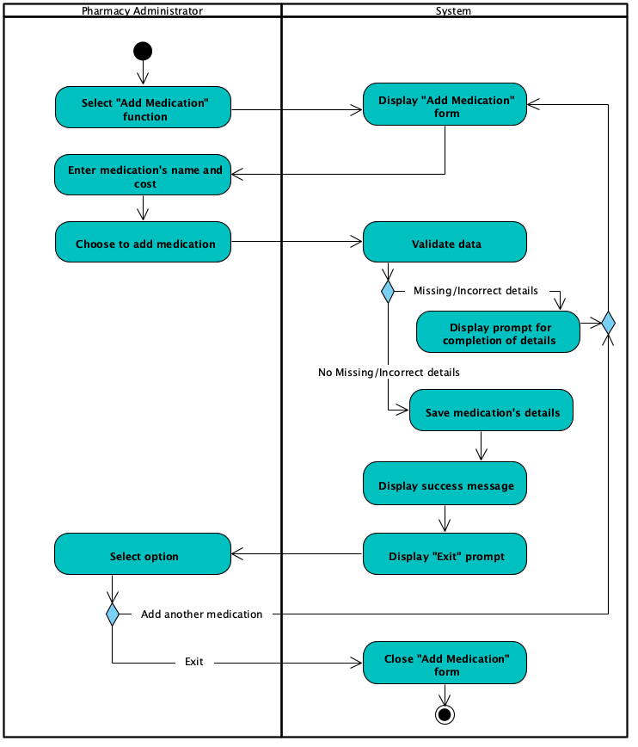

Use Case: 17 – Update Medication

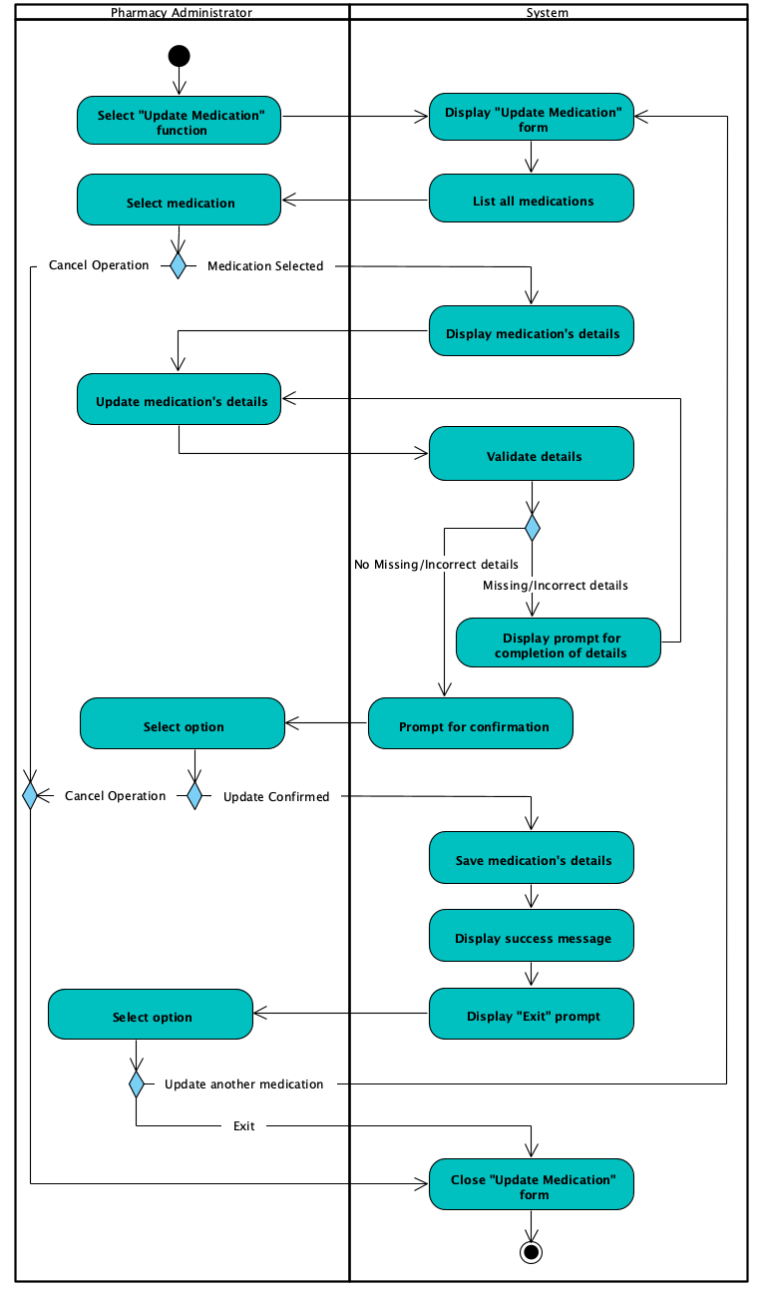

Use Case: 18 – Delete Medication

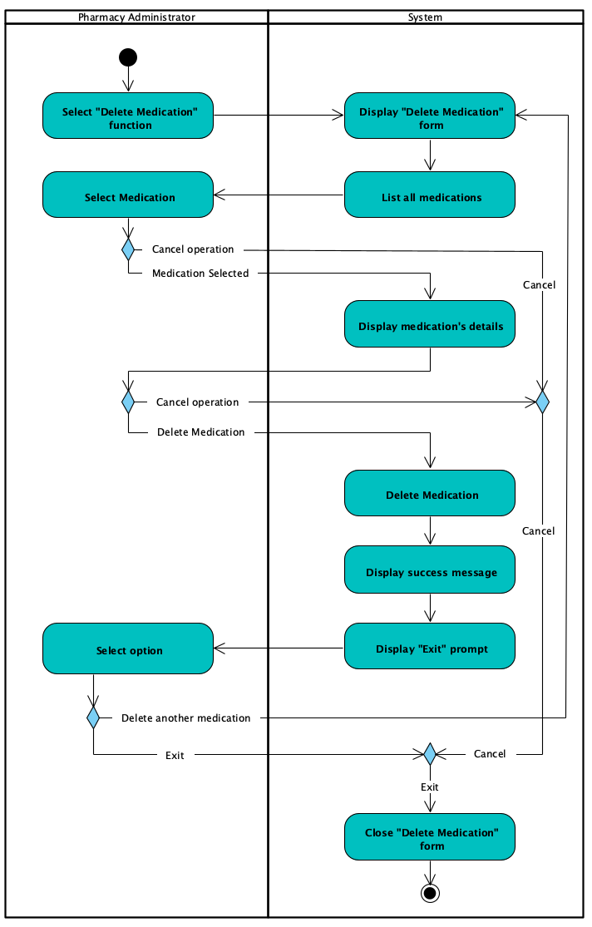

Use Case: 22 – Add Ward

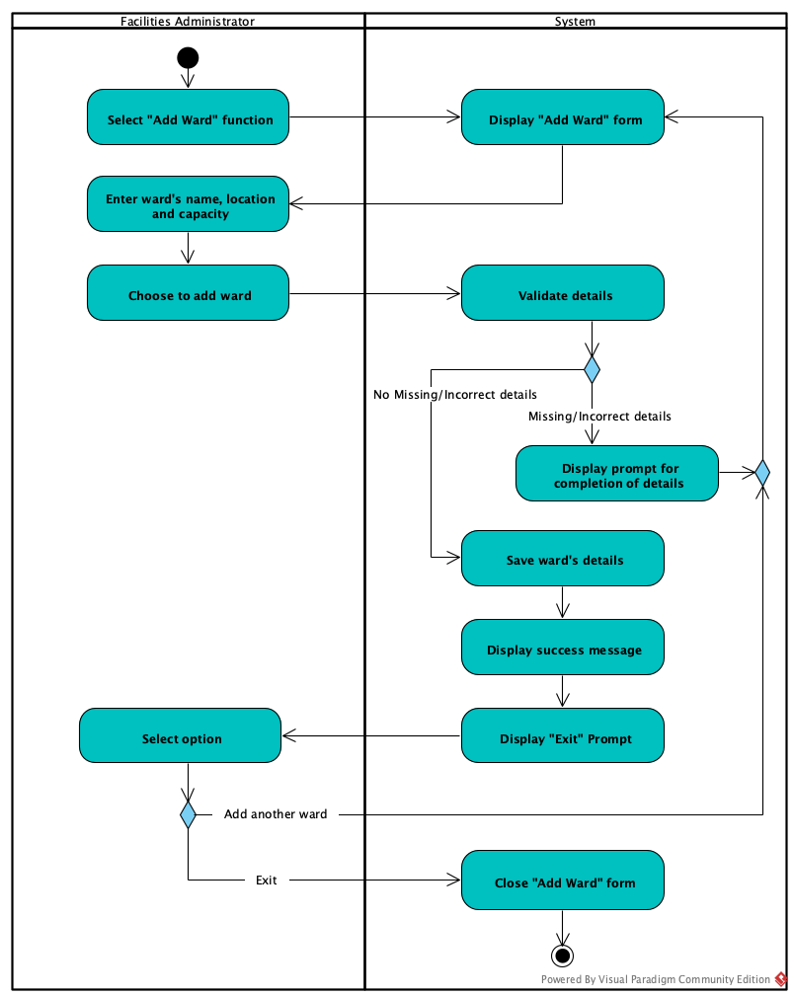

Use Case: 23 – Update Ward

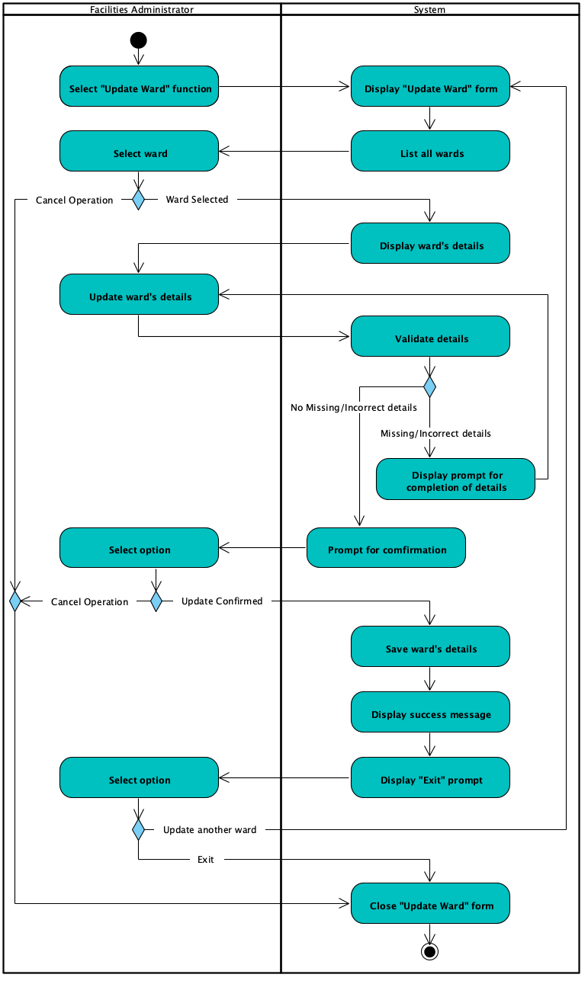

Use Case: 24 – Delete Ward

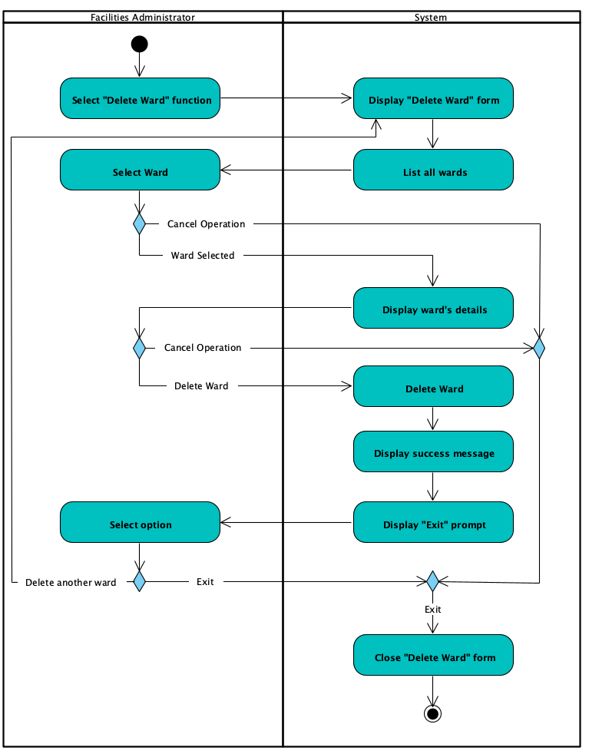

Use Case: 25 – Produce Wards Report

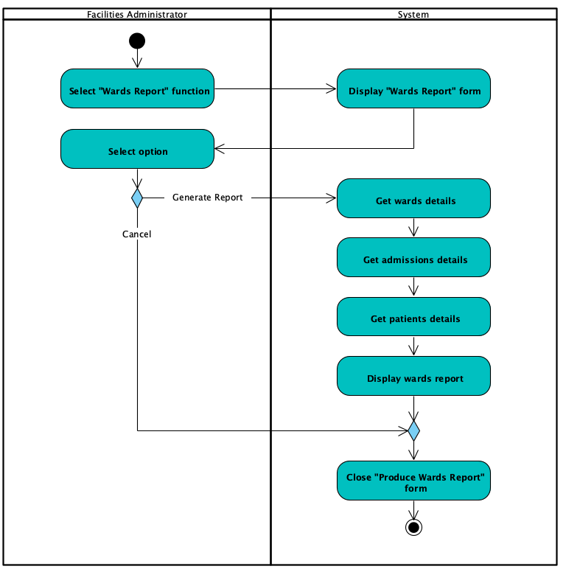

Use Case: 26 – Close Admission

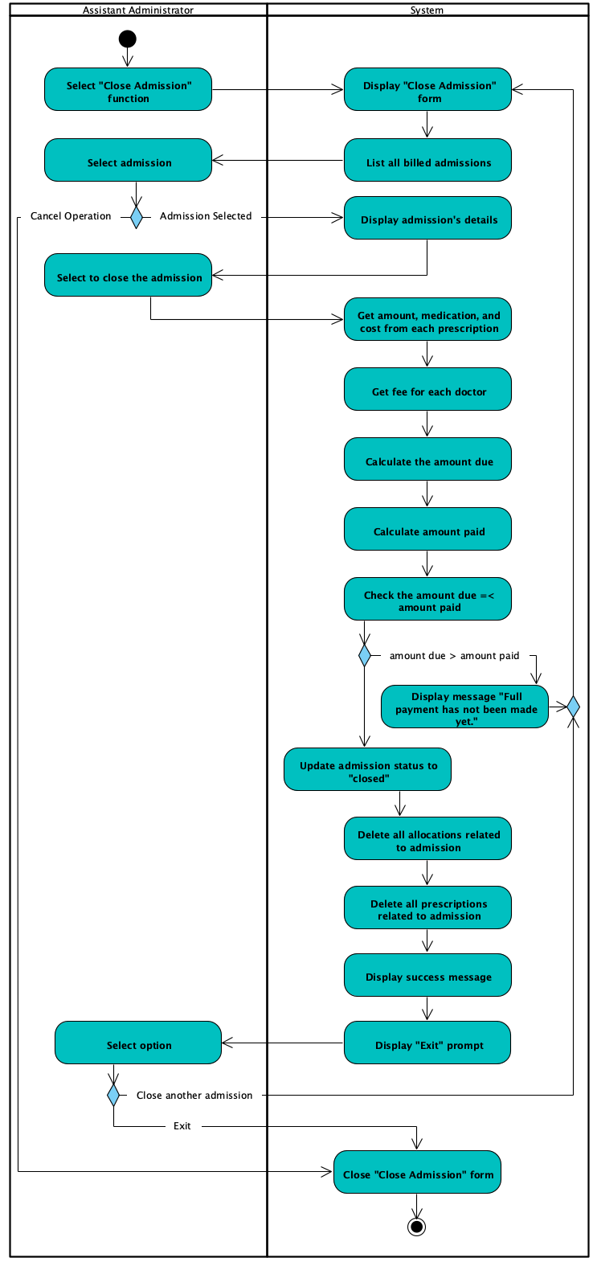

## 7.5 Overall Class Diagram

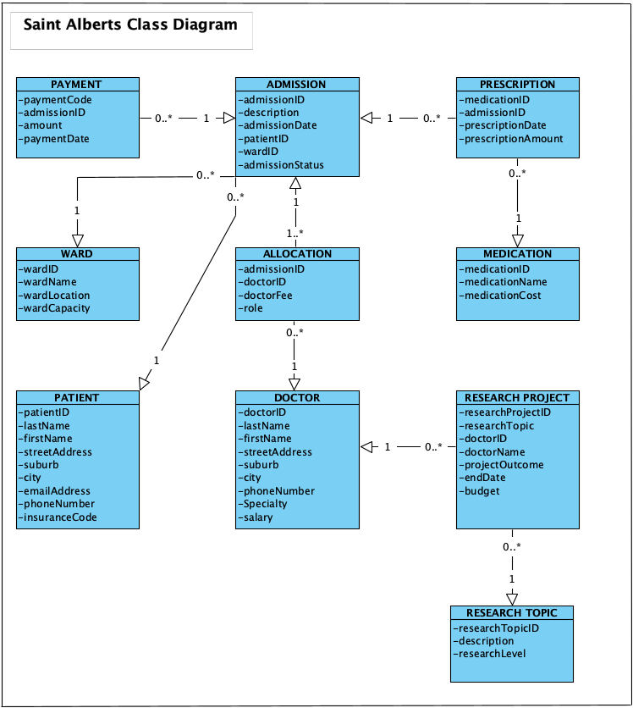

# 8. Project Design

## 8.1 Introduction

At this stage of the project and following meticulous requirement analysis, the project is ready to enter the design phase.

Having considered the practicality of the software development capacity and design limitations, business-level use cases were drafted then into design-level use cases. Additional features which could be added to the software to enhance functionality and also to meet expectations of a robust system were thought of.

Sequence diagrams would display how the steps in each use case would be ordered and define how the actors would initiate events and how the forms would respond with the controller and in relation with the involved class in the database.

A deployment diagram would show how the system which is the computer links the database to the C# application.

Then an ERD was drawn to clarify the relationship between the classes in the database and a data dictionary would supplement it bounding what attributes are required for each class. Data dictionary would also define the validation rules needed for the fields and what attributes would function as Primary and Foreign Key(s).

In order to show what the final product would look like, 8 user interface mock-ups were designed to show the appearance of the menu, forms and the report. These were annotated to convey what each feature of the form is about, what information they are supposed to hold and display, and also the size and font and colour of the fields and buttons.

Ultimately, test plans were created to establish quality assurance of the product and ensure the forms function as expected and as decided by the design use cases.

## 8.2 Software List

These are a list of the soft wares used for the execution of this project (the list is alphabetically ordered)

* Figma 2021
* Ms Access 2021
* Ms Excel 2021
* Ms Word 2021
* QuickTime Player (MACOS) 2021
* Visio Professional 2021
* Visual Paradigm Community Edition
* Visual Studio 2019

## 8.3 Version Control Software

The progress of the project and produced artefacts were regularly uploaded to:

* Github

## 8.4 Design Use Case Narratives (Descriptions)

|  |  |  |
| --- | --- | --- |
| **USE CASE NAME:** | Add Medication | **USE CASE TYPE** |
| **USE CASE ID:** | 16 | **Design Requirements: 🗹** |
| **PRIORITY:** | High |  |
| **PRIMARY BUSINESS ACTOR:** | Pharmacy Administrator | |
| **OTHER PARTICIPATING ACTORS:** | None | |
| **DESCRIPTION:** | This use case describes the pharmacy administrator adding a medication’s details. | |
| **PRE-CONDITIONS:** | The pharmacy administrator has logged onto the system. | |
| **TYPICAL COURSE** | Step 1 The pharmacy administrator selects the “Add Medication” function.  Step 2 The system displays the “Add Medication” form with all fields blank.  Step 3 The pharmacy administrator enters the medication’s name and cost.  Step 4 The pharmacy administrator clicks on the “Add Medication” button.  Step 5 The system validates the data to confirm that all necessary fields are filled in correctly.  Step 6 The system gets a unique value for the new medication ID.  Step 7 The system saves the medication’s details (medication ID, name and cost).  Step 8 The system displays the message “Medication added successfully”.  Step 9 The pharmacy administrator clicks on the “OK” button to close the success message.  Step 10 The system prompts for “Add another medication?”  Step 11 The pharmacy administrator clicks on “No”.  Step 12 The system closes the form to end the use case. | |
| **OF EVENTS:** |
|  |
|  |
|  |
|  |
| **ALTERNATE COURSES:** | Step 6a.1 The system, having identified some missing or incorrect fields, displays the message “Please fill in the fields correctly”.  Step 6a.2 The system goes to step 3. | |
| Step 11a.1 The pharmacy administrator elects to add another medication.  Step 11a.2 The system goes to step 2. | |
| **POST CONDITIONS:** | None | |
| **ASSUMPTIONS:** | None | |

|  |  |  |
| --- | --- | --- |
| **USE CASE NAME:** | Update Medication | **USE CASE TYPE** |
| **USE CASE ID:** | 17 | **Design Requirements: 🗹** |
| **PRIORITY:** | High |  |
| **PRIMARY BUSINESS ACTOR:** | Pharmacy Administrator | |
| **OTHER PARTICIPATING ACTORS:** | None | |
| **DESCRIPTION:** | This use case describes the pharmacy administrator updating a selected medication’s details. | |
| **PRE-CONDITIONS:** | The pharmacy administrator has logged onto the system. | |
| **TYPICAL COURSE** | Step 1 The pharmacy administrator selects the “Update Medication” function.  Step 2 The system displays the “Update Medication” form.  Step 3 The system gets all the medications.  Step 4 The system displays the list of all the medications (medication ID and medication name).  Step 5 The pharmacy administrator selects the medication whose details require updating.  Step 6 The system gets the selected medication’s details.  Step 7 The system displays the medication’s details (medication ID, medication name, and cost).  Step 8 The pharmacy administrator updates the relevant details (medication name and cost only).  Step 9 The pharmacy administrator clicks on the “Update Medication” button.  Step 10 The system validates the entries in the fields.  Step 11 The system prompts for confirmation to change the medication’s details.  Step 12 The pharmacy administrator confirms the change of details.  Step 13 The system saves and updates the medication’s details (medication ID, medication name, and cost).  Step 14 The system displays the “Medication updated successfully” message.  Step 15 The pharmacy administrator clicks on “OK” to close the success message.  Step 16 The system prompts for “Update another medication?”  Step 17 The pharmacy administrator clicks on “No”.  Step 18 The pharmacy administrator clicks on the “Return” button to close the form.  Step 19 The system closes the form to end the use case. | |
| **OF EVENTS:** |
|  |
|  |
|  |
|  |
| **ALTERNATE COURSES:** | Step 5a.1 The pharmacy administrator clicks on the “Return” button to cancel.  Step 5a.2 The system goes to step 19. | |
| Step 11a.1 The system, having identified some missing or incorrect fields, displays the message “Please fill in the fields correctly”.  Step 11a.2 The system goes to step 8. | |
| Step 12a.1 The pharmacy administrator elect to cancel the changes by clicking on “No”.  Step 12a.2 The system goes to Step 19. | |
| Step 17a.1 The pharmacy administrator elects to update another medication.  Step 17a.2 The system goes to step 2. | |
| **POST CONDITIONS:** | None | |
| **ASSUMPTIONS:** | None | |
| **USE CASE NAME:** | Delete Medication | **USE CASE TYPE** |
| **USE CASE ID:** | 18 | **Design Requirements: 🗹** |
| **PRIORITY:** | High |  |
| **PRIMARY BUSINESS ACTOR:** | Pharmacy Administrator | |
| **OTHER PARTICIPATING ACTORS:** | None | |
| **DESCRIPTION:** | This use case describes the pharmacy administrator deleting a selected medication’s details. | |
| **PRE-CONDITIONS:** | The pharmacy administrator has logged onto the system. | |
| **TYPICAL COURSE** | Step 1 The pharmacy administrator selects the “Delete Medication” function.  Step 2 The system displays the “Delete Medication” form.  Step 3 The system gets all of the medications.  Step 4 The system displays the list of all the medications (medication ID and medication name) that are not linked to any prescriptions.  Step 5 The pharmacy administrator selects the medication whose details require deleting.  Step 6 The system gets the selected medication’s details.  Step 7 The system displays the medication’s details (medication ID, medication name, and cost).  Step 8 The pharmacy administrator clicks on the “Delete Medication” button.  Step 9 The system deletes the medication’s details.  Step 10 The system displays the “Medication deleted successfully” message.  Step 11 The pharmacy administrator clicks on “OK” to close the success message.  Step 12 The system prompts for “Delete another medication?”  Step 13 The pharmacy administrator clicks on “No”.  Step 14 The pharmacy administrator clicks on the “Return” button to close the form.  Step 15 The system closes the form to end the use case. | |
| **OF EVENTS:** |
|  |
|  |
|  |
|  |
| **ALTERNATE COURSES:** | Step 5a.1 The pharmacy administrator clicks on the “Return” button to cancel the operation.  Step 5a.2 The system goes to step 15. | |
| Step 8a.1 The pharmacy administrator clicks on the “Return” button to cancel the operation.  Step 8a.2 The system goes to step 15. | |
| Step 13a.1 The pharmacy administrator elects to delete another medication.  Step 13a.2 The system goes to step 2. | |
| **POST CONDITIONS:** | None | |
| **ASSUMPTIONS:** | None | |

|  |  |  |
| --- | --- | --- |
| **USE CASE NAME:** | Add Ward | **USE CASE TYPE** |
| **USE CASE ID:** | 22 | **Design Requirements: 🗹** |
| **PRIORITY:** | High |  |
| **PRIMARY BUSINESS ACTOR:** | Facilities Administrator | |
| **OTHER PARTICIPATING ACTORS:** | None | |
| **DESCRIPTION:** | This use case describes the facilities administrator adding a ward’s details. | |
| **PRE-CONDITIONS:** | The facilities administrator has logged onto the system. | |
| **TYPICAL COURSE** | Step 1 The facilities administrator selects the “Add Ward” function.  Step 2 The system displays the “Add Ward” form with all fields blank.  Step 3 The facilities administrator enters the ward’s name, location and capacity.  Step 4 The facilities administrator clicks on the “Add Ward” button.  Step 5 The system validates the data to confirm that the details are filled in correctly.  Step 6 The system gets a unique value for the new ward ID.  Step 7 The system saves the ward’s details (ward ID, ward name, location, and capacity).  Step 8 The system displays the message “Ward added successfully”.  Step 9 The facilities administrator clicks on the “OK” button to close the success message.  Step 10 The system prompts for “Add another ward?”  Step 11 The facilities administrator clicks on “No”.  Step 12 The system closes the form to end the use case. | |
| **OF EVENTS:** |
|  |
|  |
|  |
|  |
| **ALTERNATE COURSES:** | Step 4a.1 The facilities administrator clicks on the “Return” button to cancel the operation.  Step 4a.2 The system goes to step 12. | |
| Step 6a.1 The system, having identified some missing or incorrect fields, displays the message “Please fill in the fields correctly”.  Step 6a.2 The system goes to step 3. | |
| Step 11a.1 The facilities administrator elects to add another ward.  Step 11a.2 The system goes to step 2. | |
| **POST CONDITIONS:** | None | |
| **ASSUMPTIONS:** | None | |

|  |  |  |  |
| --- | --- | --- | --- |
| **USE CASE NAME:** | Update Ward | **USE CASE TYPE** | |
| **USE CASE ID:** | 23 | **Design Requirements: 🗹** | |
| **PRIORITY:** | High |  | |
| **PRIMARY BUSINESS ACTOR:** | Facilities Administrator | | |
| **OTHER PARTICIPATING ACTORS:** | None | | |
| **DESCRIPTION:** | This use case describes the facilities administrator updating a selected ward’s details. | | |
| **PRE-CONDITIONS:** | The facilities administrator has logged onto the system. | | |
| **TYPICAL COURSE** | Step 1 The facilities administrator selects the “Update Ward” function.  Step 2 The system displays the “Update Ward” form.  Step 3 The system gets all the wards.  Step 4 The system displays a list of all the wards (ward ID and ward name).  Step 5 The facilities administrator selects the ward whose details require updating.  Step 6 The system gets the selected ward’s details.  Step 7 The system displays the ward’s details (ward ID, ward name, location, and capacity).  Step 8 The facilities administrator updates the relevant details (name, location, and capacity only).  Step 9 The facilities administrator clicks on the “Update Ward” button.  Step 10 The system validates the entries in the fields.  Step 11 The system prompts for confirmation to change the ward’s details.  Step 12 The facilities administrator confirms the change of details.  Step 13 The system saves and updates the ward’s details (ward ID, name, location and capacity only).  Step 14 The system displays the “Ward updated successfully” message.  Step 15 The facilities administrator clicks on “OK” button to close the success message.  Step 16 The system prompts for “Update another ward?”  Step 17 The facilities administrator clicks on “No”.  Step 18 The facilities administrator clicks on the “Return” button to close the form.  Step 19 The system closes the form to end the use case. | | |
| **OF EVENTS:** |
|  |
|  |
|  |
|  |
| **ALTERNATE COURSES:** | Step 5a.1 The facilities administrator clicks on the “Return” button to cancel the operation.  Step 5a.2 The system goes to step 19. | | |
| Step 11a.1 The system, having identified some missing or incorrect fields, displays the message “Please fill in the fields correctly”.  Step 11a.2 The system goes to step 8. | | |
| Step 12a.1 The facilities administrator elect to cancel the changes by clicking on “No”.  Step 12a.2 The system goes to step 19. | | |
| Step 17a.1 The facilities administrator elects to update another ward.  Step 17a.2 The system goes to step 2. | | |
| **POST CONDITIONS:** | None | | |
| **ASSUMPTIONS:** | None | | |
| **USE CASE NAME:** | Delete Ward | **USE CASE TYPE** |
| **USE CASE ID:** | 24 | **Design Requirements: 🗹** |
| **PRIORITY:** | High |  |
| **PRIMARY BUSINESS ACTOR:** | Facilities Administrator | |
| **OTHER PARTICIPATING ACTORS:** | None | |
| **DESCRIPTION:** | This use case describes the facilities administrator deleting a selected ward’s details. | |
| **PRE-CONDITIONS:** | The facilities administrator has logged onto the system. | |
| **TYPICAL COURSE** | Step 1 The facilities administrator selects the “Delete Ward” function.  Step 2 The system displays the “Delete Ward” form.  Step 3 The system gets all of the wards.  Step 4 The system displays the list of all the wards (ward ID, and name) that are not linked to any admissions.  Step 5 The facilities administrator selects the ward whose details require deleting.  Step 6 The system gets the selected ward’s details.  Step 7 The system displays the ward’s details (ward ID, name, location and capacity).  Step 8 The facilities administrator clicks on the “Delete Ward” button.  Step 9 The system deletes the ward’s details.  Step 10 The system displays the “Ward deleted successfully” message.  Step 11 The facilities administrator clicks on “OK” to close the success message.  Step 12 The system prompts for “Delete another ward?”  Step 13 The facilities administrator clicks on “NO”.  Step 14 The facilities administrator clicks on the “Return” button to close the form.  Step 15 The system closes the form to end the use case. | |
| **OF EVENTS:** |
|  |
|  |
|  |
|  |
| **ALTERNATE COURSES:** | Step 5a.1 The facilities administrator clicks on the “Return” button.  Step 5a.2 The system goes to step 15. | |
| Step 8a.1 The facilities administrator elect to cancel the operation.  Step 8a.2 The system goes to step 15. | |
| Step 13a.1 The facilities administrator elects to delete another ward.  Step 13a.2 The system goes to step 2. | |
| **POST CONDITIONS:** | None | |
| **ASSUMPTIONS:** | None | |

|  |  |  |
| --- | --- | --- |
| **USE CASE NAME:** | Produce Wards Report | **USE CASE TYPE** |
| **USE CASE ID:** | 25 | **Design Requirements: 🗹** |
| **PRIORITY:** | High |  |
| **PRIMARY BUSINESS ACTOR:** | Facilities Administrator | |
| **OTHER PARTICIPATING ACTORS:** | None | |
| **DESCRIPTION:** | This use case describes the facilities administrator producing the wards report. | |
| **PRE-CONDITIONS:** | The facilities administrator has logged onto the system. | |
| **TYPICAL COURSE** | Step 1 The facilities administrator selects the “Wards Report” function.  Step 2 The system displays the “Wards Report” form.  Step 3 The facilities administrator clicks on the “Generate Report” button.  Step 4 The system gets the details (ward ID, ward name, location, and capacity) of each ward.  Step 4.1 The system gets all of the current admissions linked to each ward.  Step 4.2 The system gets the details (patient ID, last name, and first name) of the patient linked to each admission.  Step 5 The system displays the wards report (ward ID, ward name, location, and capacity) plus patient ID, last name, and first name (for each current admission) for each ward sorted by ward name.  Step 6 The facilities administrator clicks on the “Return” button.  Step 7 The system closes the form to end the use case.. | |
| **OF EVENTS:** |
|  |
|  |
|  |
|  |
| **ALTERNATE COURSES:** | Step 3a.1 The facilities administrator clicks on “Return” button to cancel, without generating the report.  Step 3a.2 The system goes to step 7. | |
| **POST CONDITIONS:** | None | |
| **ASSUMPTIONS:** | None | |

|  |  |  |
| --- | --- | --- |
| **USE CASE NAME:** | Close Admission | **USE CASE TYPE** |
| **USE CASE ID:** | 26 | **Design Requirements: 🗹** |
| **PRIORITY:** | High |  |
| **PRIMARY BUSINESS ACTOR:** | Assistant Administrator | |
| **OTHER PARTICIPATING ACTORS:** | None | |
| **DESCRIPTION:** | This use case describes the assistant administrator closing a selected admission. | |
| **PRE-CONDITIONS:** | The assistant administrator has logged onto the system. | |
| **TYPICAL COURSE** | Step 1 The assistant administrator selects the “Close Admission” function.  Step 2 The system displays the “Close Admission” form.  Step 3 The system gets all of the billed admissions.  Step 4 The system displays a list of all the billed admissions (admission ID and description) that have payments.  Step 5 The assistant administrator selects the admission to close.  Step 6 The system gets the admission’s details.  Step 7 The system displays the admission’s details (admission ID, description, and admission date).  Step 8 The assistant administrator clicks on the “Close Admission” button.  Step 9 The system gets the amount, medication and cost from each prescription for the admission.  Step 10 The system gets the fee for each doctor allocated to the admission.  Step 11 The system calculates the amount due by summing the product of each prescription’s amount and medication’s cost and adding it to the sum of the doctor’s fees.  Step 12 The system calculates the amount paid (the sum of all payments made) on the admission.  Step 13 The system check that the amount due is equal to or less than the amount paid.  Step 14 The system updates the status of the admission to closed.  Step 15 The system deletes all allocations related to the admission.  Step 16 The system deletes all prescriptions related to the admission.  Step 17 The system displays the message “Admission closed successfully”.  Step 18 The assistant administrator clicks on the “Return” button.  Step 19 The system closes the form to end the use case. | |
| **OF EVENTS:** |
|  |
|  |
|  |
|  |
| **ALTERNATE COURSES:** | Step 5a.1 The assistant administrator clicks on the “Return” button to cancel the operation.  Step 5a.2 The system goes to step 19. | |
| Step 14a.1 The system, having determined that the amount due is greater than the amount paid, displays the message “Full payment has not been made yet.”  Step 14a.2 The system goes to step 2. | |
| Step 18a.1 The assistant administrator elects to close another admission.  Step 18a.2 The system goes to step 2. | |
| **POST CONDITIONS:** | The admission’s status is set to closed. | |
| **ASSUMPTIONS:** | None | |

## 8.5 Sequence Diagrams

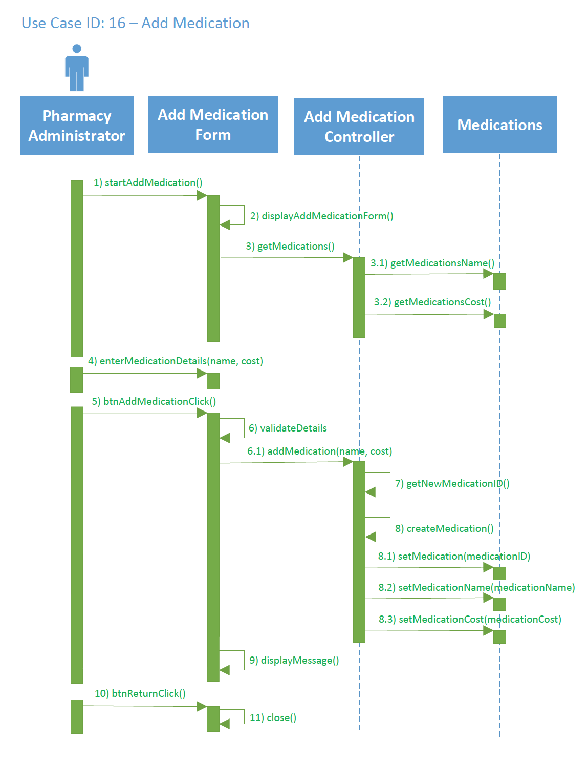

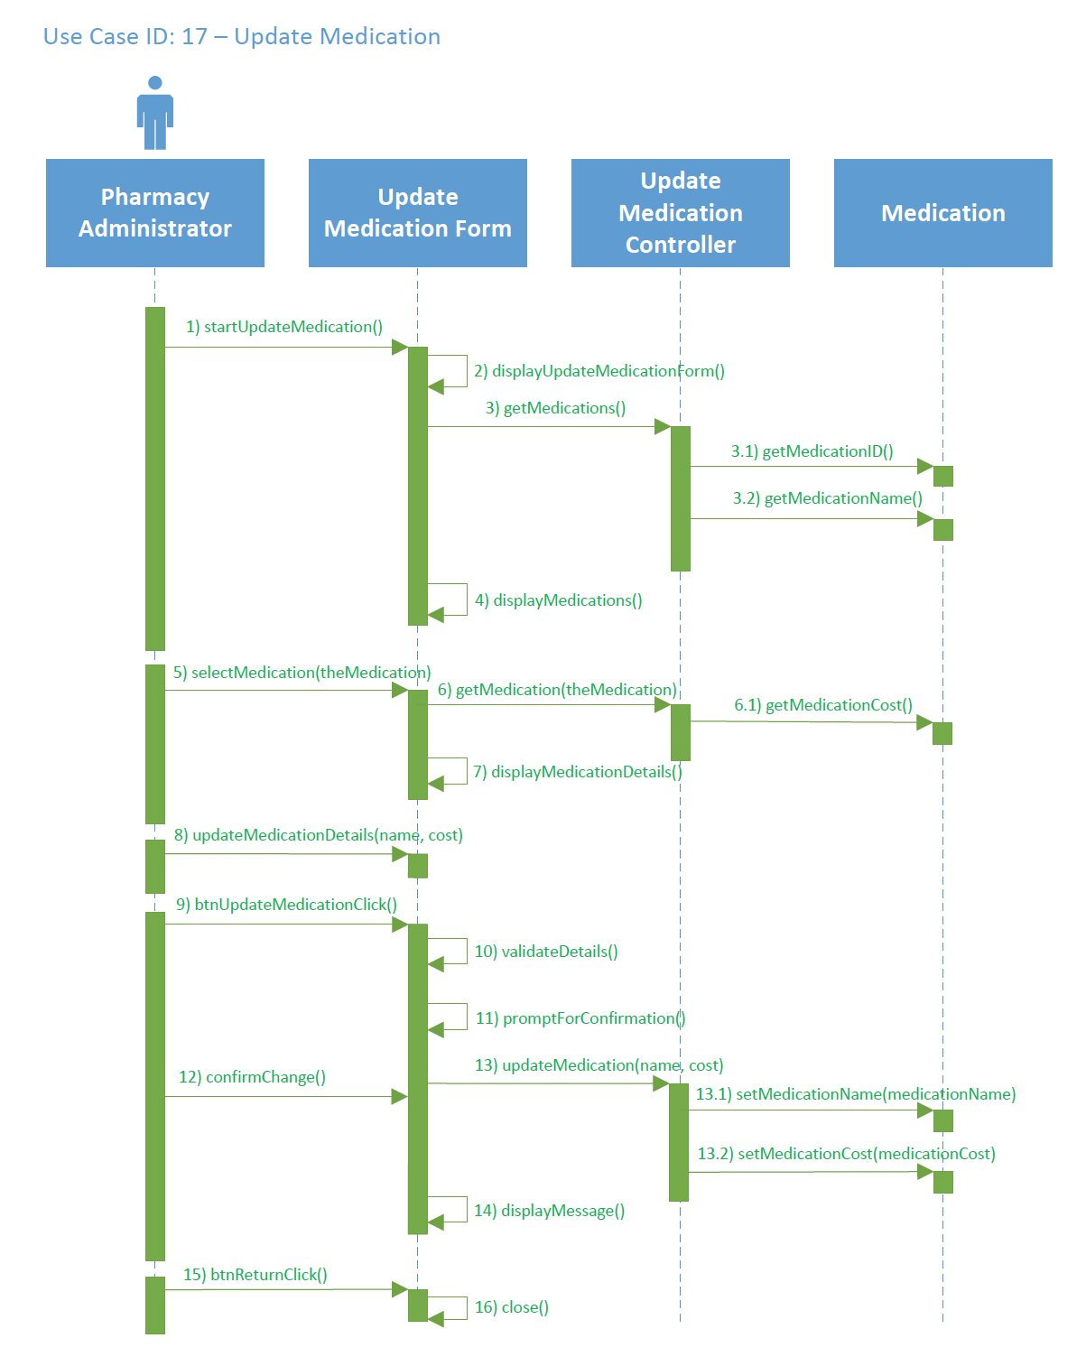

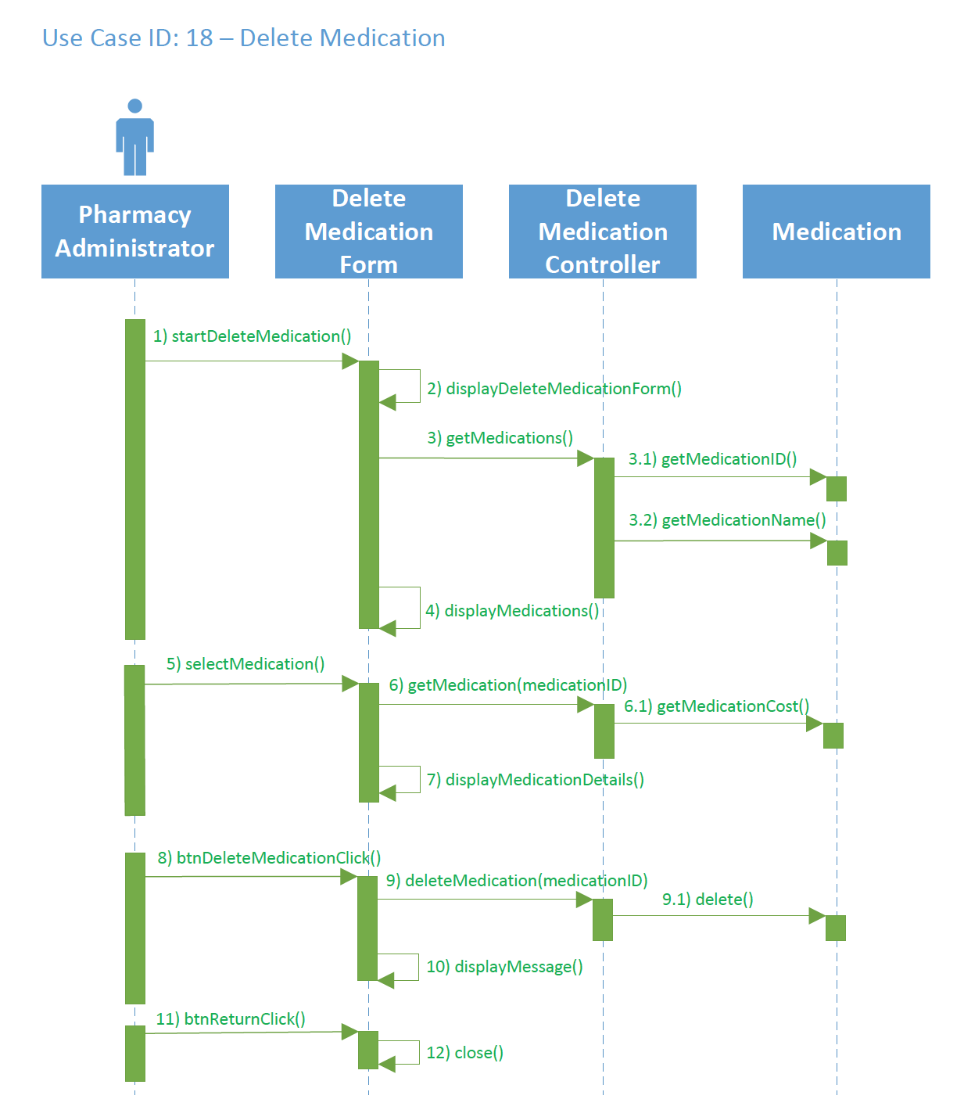

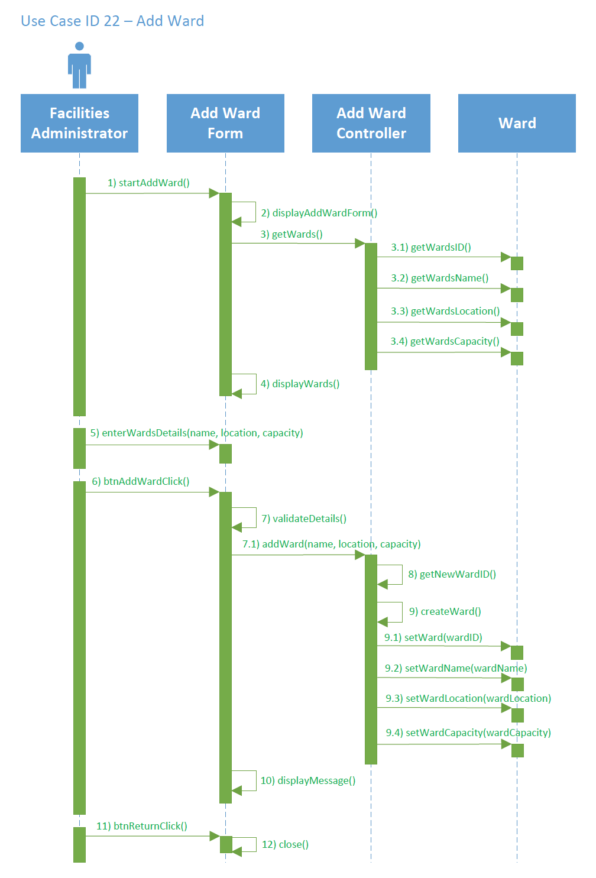

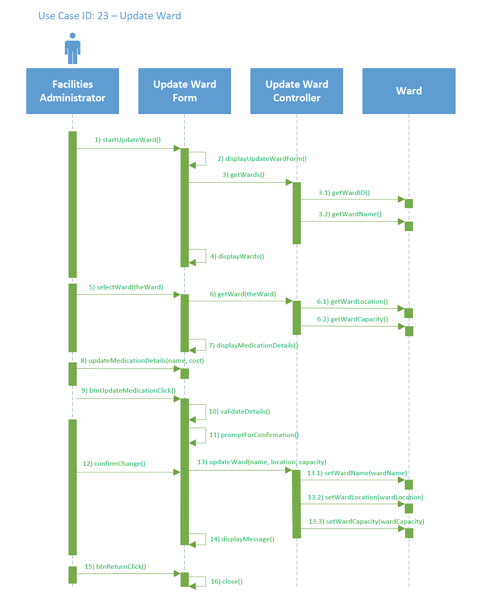

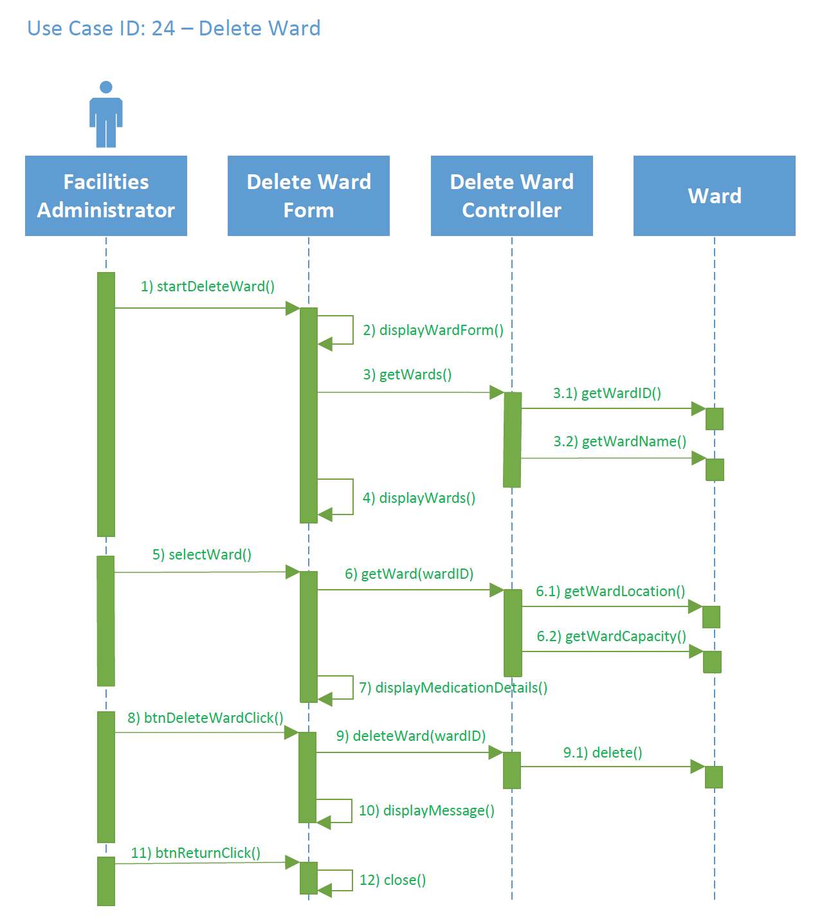

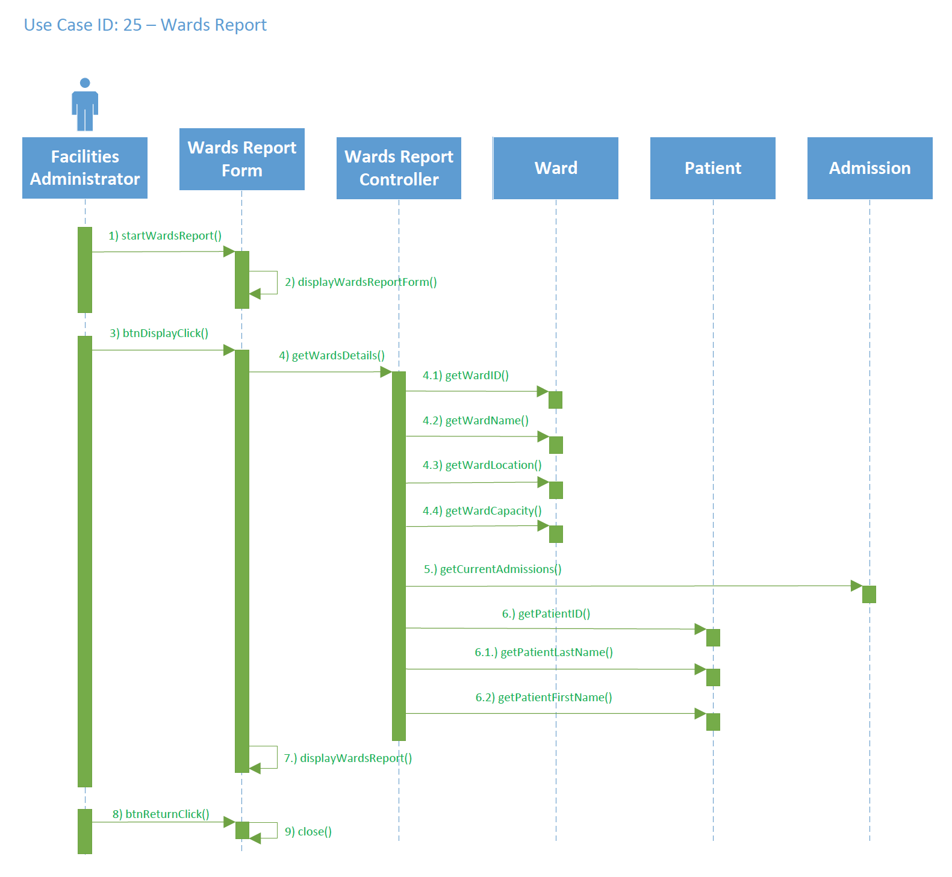

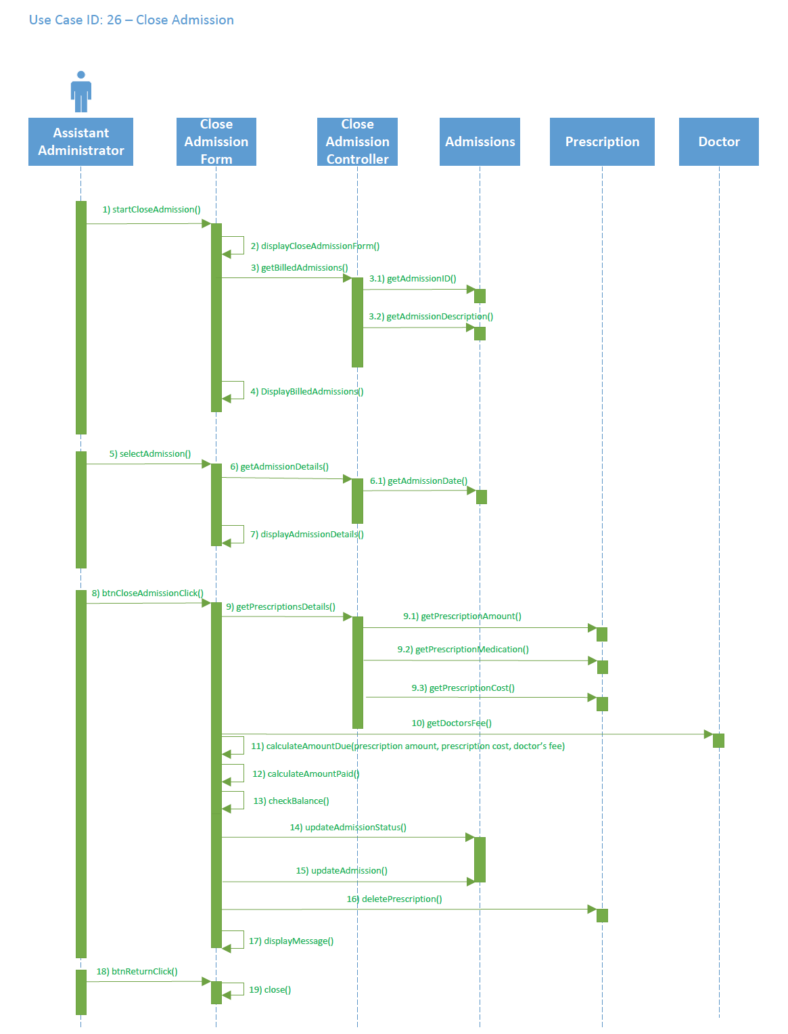

## 8.6 Deployment Diagram

This diagram lay out the relationship between the system, database and data stored together with the C# application which will perform tasks.

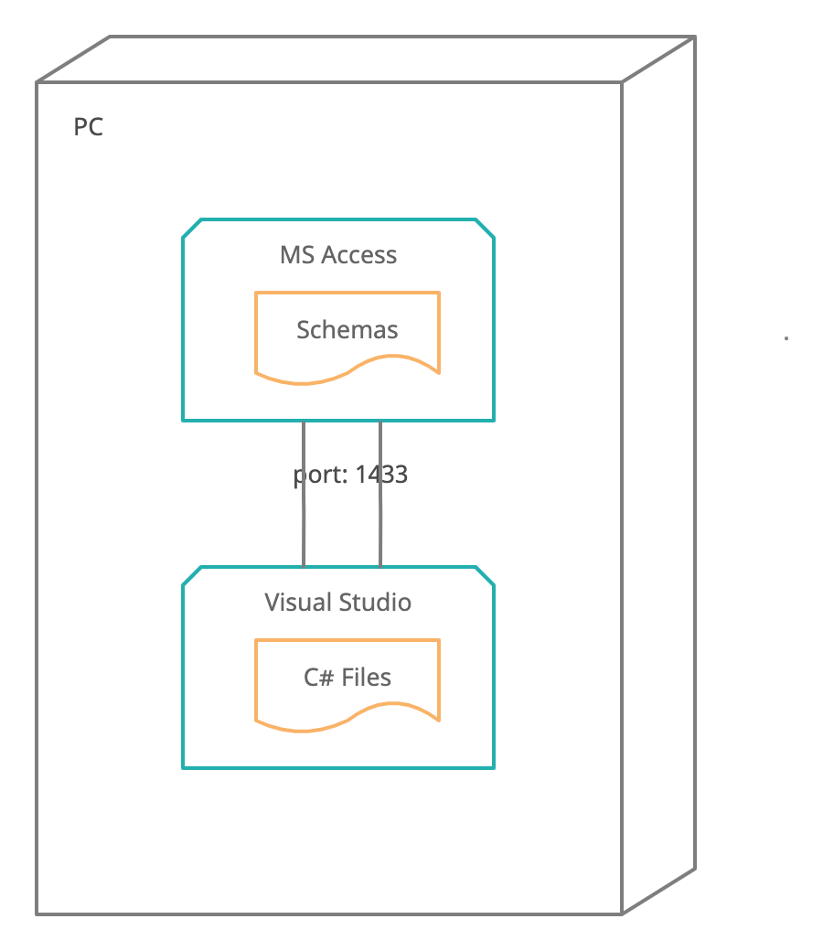

## 8.7 Database Design

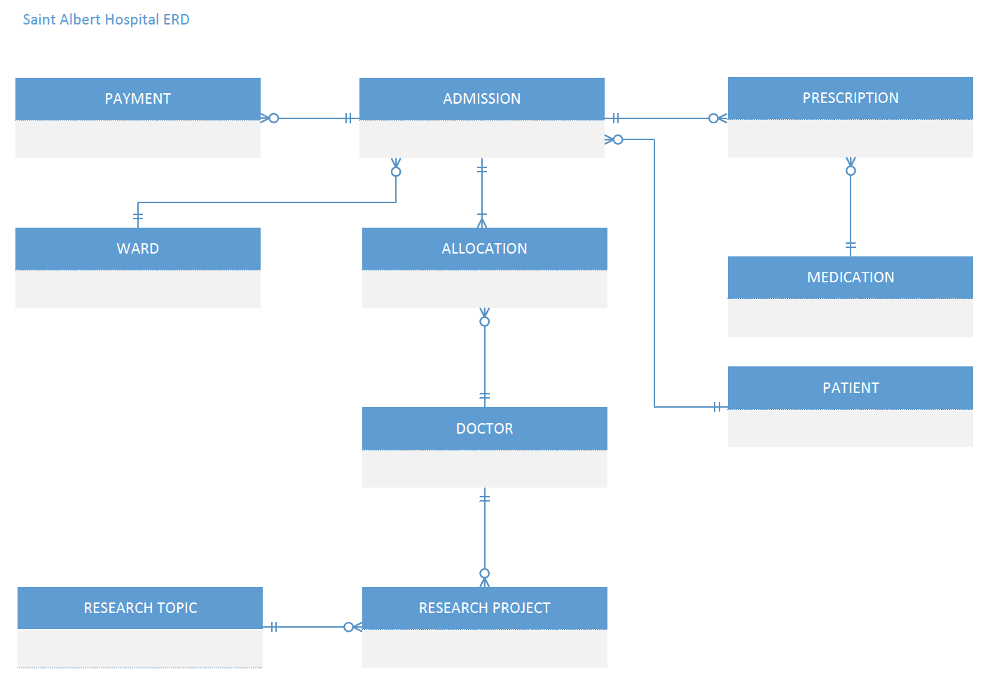

**Data Dictionary**

**WARD**

|  |  |  |  |  |
| --- | --- | --- | --- | --- |
| **Name** | **Required** | **Data Type** | **Maximum Length** | **Range/List** |
| **WardID** | **Yes** | **Auto Number** | **2** | **Primary Key**  **1 – 99 inclusive** |
| **WardName** | **Yes** | **Text** | **10** | **-** |
| **WardLocation** | **Yes** | **Text** | **8** | **-** |
| **WardCapacity** | **Yes** | **Number** | **2** | **1 – 20 inclusive** |

**PATIENT**

|  |  |  |  |  |
| --- | --- | --- | --- | --- |
| **Name** | **Required** | **Data Type** | **Maximum Length** | **Range/List** |
| **PatientID** | **Yes** | **Auto Number** | **6** | **Primary Key**  **1 - 99999999 inclusive** |
| **LastName** | **Yes** | **Text** | **25** | **-** |
| **FirstName** | **Yes** | **Text** | **25** | **-** |
| **StreetAddress** | **Yes** | **Text** | **50** | **-** |
| **Suburb** | **Yes** | **Text** | **20** | **-** |
| **City** | **Yes** | **Text** | **20** | **-** |
| **EmailAddress** | **Yes** | **Text** | **30** | **-** |
| **PhoneNumber** | **No** | **Number** | **15** | **-** |
| **InsuranceCode** | **Yes** | **Text** | **15** | **-** |

**DOCTOR**

|  |  |  |  |  |
| --- | --- | --- | --- | --- |
| **Name** | **Required** | **Data Type** | **Maximum Length** | **Range/List** |
| **DoctorID** | **Yes** | **Auto Number** | **6** | **Primary Key** |
| **LastName** | **Yes** | **Text** | **25** | **-** |
| **FirstName** | **Yes** | **Text** | **25** | **-** |
| **StreetAddress** | **Yes** | **Text** | **50** | **-** |
| **Suburb** | **Yes** | **Text** | **20** | **-** |
| **City** | **Yes** | **Text** | **20** | **-** |
| **PhoneNumber** | **Yes** | **Number** | **15** | **-** |
| **Specialty** | **Yes** | **Text** | **15** | **-** |
| **Salary** | **Yes** | **Number** | **6** | **20,000.00 - 200,000.00 inclusive** |

**RESEARCH TOPIC**

|  |  |  |  |  |
| --- | --- | --- | --- | --- |
| **Name** | **Required** | **Data Type** | **Maximum Length** | **Range/List** |
| **ResearchTopicID** | **Yes** | **Auto Number** | **6** | **Primary Key**  **1 – 999 inclusive** |
| **Description** | **Yes** | **Text** | **100** | **-** |
| **ResearchLevel** | **Yes** | **Number** | **2** | **1 – 10 inclusive** |

**MEDICATION**

|  |  |  |  |  |
| --- | --- | --- | --- | --- |
| **Name** | **Required** | **Data Type** | **Maximum Length** | **Range/List** |
| **MedicationID** | **Yes** | **Auto Number** | **6** | **Primary Key**  **1 – 999999 inclusive** |
| **MedicationName** | **Yes** | **Text** | **25** | **-** |
| **MedicationCost** | **Yes** | **Currency** | **7** | **0.50 – 9999.00 inclusive** |

**ADMISSION**

|  |  |  |  |  |
| --- | --- | --- | --- | --- |
| **Name** | **Required** | **Data Type** | **Maximum Length** | **Range/List** |
| **AdmissionID** | **Yes** | **Auto Number** | **8** | **Primary Key**  **1 – 99999999 inclusive** |
| **Description** | **Yes** | **Text** | **100** | **-** |
| **AdmissionDate** | **Yes** | **Date** | **10** | **Format: DD/MM/YYYY** |
| **PatientID** | **Yes** | **Foreign Key (PATIENT)** | **6** | **-** |
| **WardID** | **Yes** | **Foreign Key (WARD)** | **6** | **-** |
| **AdmissionStatus** | **Yes** | **Text** | **8** | **Current, Complete** |

**ALLOCATION**

|  |  |  |  |  |
| --- | --- | --- | --- | --- |
| **Name** | **Required** | **Data Type** | **Maximum Length** | **Range/List** |
| **AdmissionID** | **Yes** | **Foreign Key (ADMISSION)** | **6** | **Primary Key** |
| **DoctorID** | **Yes** | **Foreign Key (DOCTOR)** | **8** | **Primary Key** |
| **DoctorFee** | **Yes** | **Currency** | **6** | **10.00 – 500.00 inclusive** |
| **Role** | **Yes** | **Text** | **9** | **Primary, Secondary** |

**PRESCRIPTION**

|  |  |  |  |  |
| --- | --- | --- | --- | --- |
| **Name** | **Required** | **Data Type** | **Maximum Length** | **Range/List** |
| **MedicationID** | **Yes** | **Foreign Key (MEDICATION)** | **6** | **Primary Key** |
| **AdmissionID** | **Yes** | **Foreign Key (ADMISSION)** | **6** | **Primary Key** |
| **PrescriptionDate** | **Yes** | **Date** | **10** | **Format: DD/MM/YYYY (Today’s Date)** |
| **PrescriptionAmount** | **Yes** | **Number** | **8** | **1 – 150 inclusive** |

**RESEARCH PROJECT**

|  |  |  |  |  |
| --- | --- | --- | --- | --- |
| **Name** | **Required** | **Data Type** | **Maximum Length** | **Range/List** |
| **ResearchProjectID** | **Yes** | **Auto Number** | **6** | **Primary Key** |
| **ResearchTopicID** | **Yes** | **Foreign Key (RESEARCH TOPIC)** | **6** | **-** |
| **DoctorID** | **Yes** | **Foreign Key (DOCTOR)** | **6** | **-** |
| **DoctorName** | **Yes** | **Text** | **50** | **-** |
| **ProjectOutcome** | **Yes** | **Text** | **25** | **Journal article, Conference paper, Conference poster, Book chapter, and Book** |
| **EndDate** | **Yes** | **Date** | **10** | **Format: DD/MM/YYYY** |
| **Budget** | **Yes** | **Currency** | **8** | **2000.00 – 1000000.00 inclusive** |

**PAYMENT**

|  |  |  |  |  |
| --- | --- | --- | --- | --- |
| **Name** | **Required** | **Data Type** | **Maximum Length** | **Range/List** |
| **PaymentCode** | **Yes** | **Auto Number** | **6** | **Primary Key**  **1 – 99999999 inclusive** |
| **AdmissionID** | **Yes** | **Foreign Key (ADMISSION)** | **6** |  |
| **Amount** | **Yes** | **Currency** | **10** |  |
| **PaymentDate** | **Yes** | **Date** | **10** | **Format: DD/MM/YYYY** |

## 8.8 Annotated User Interface Designs

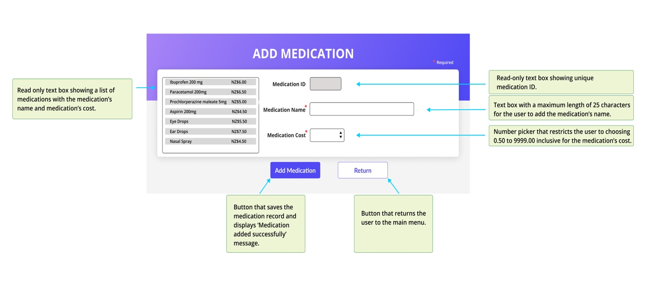

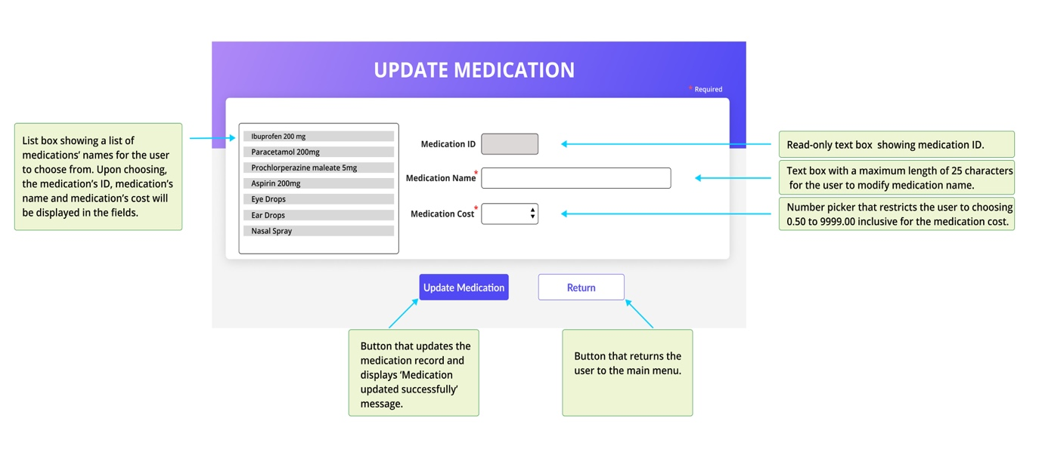

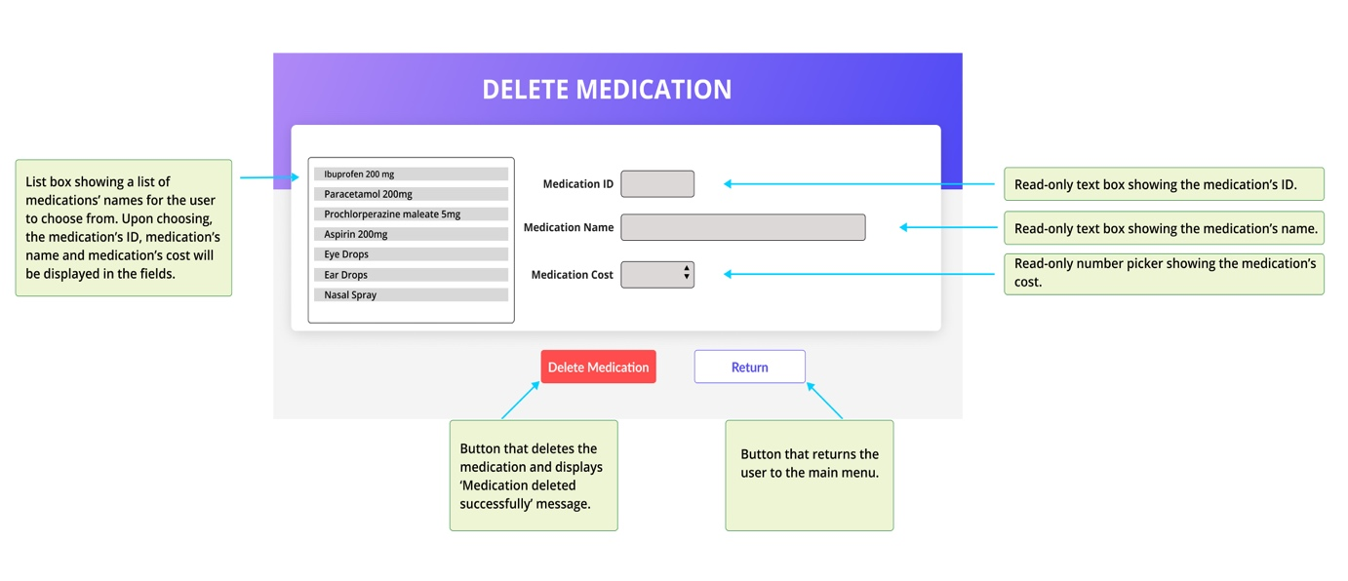

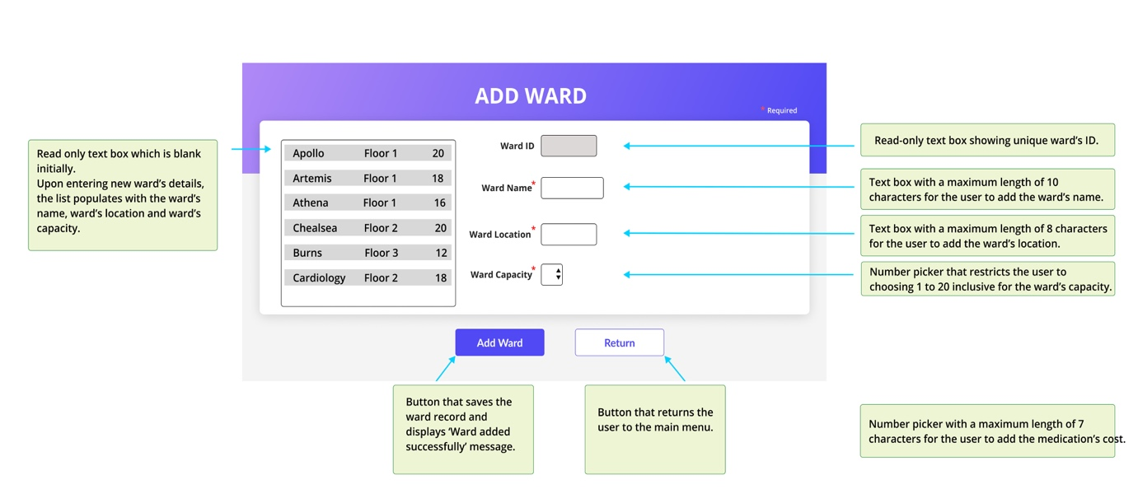

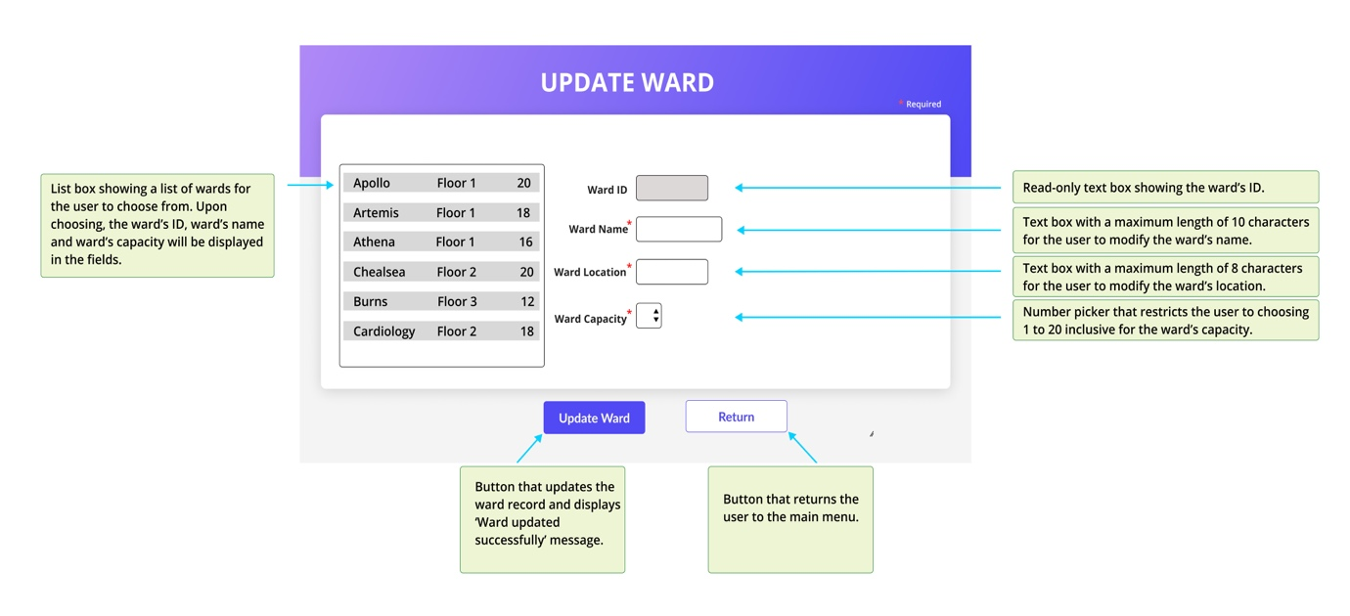

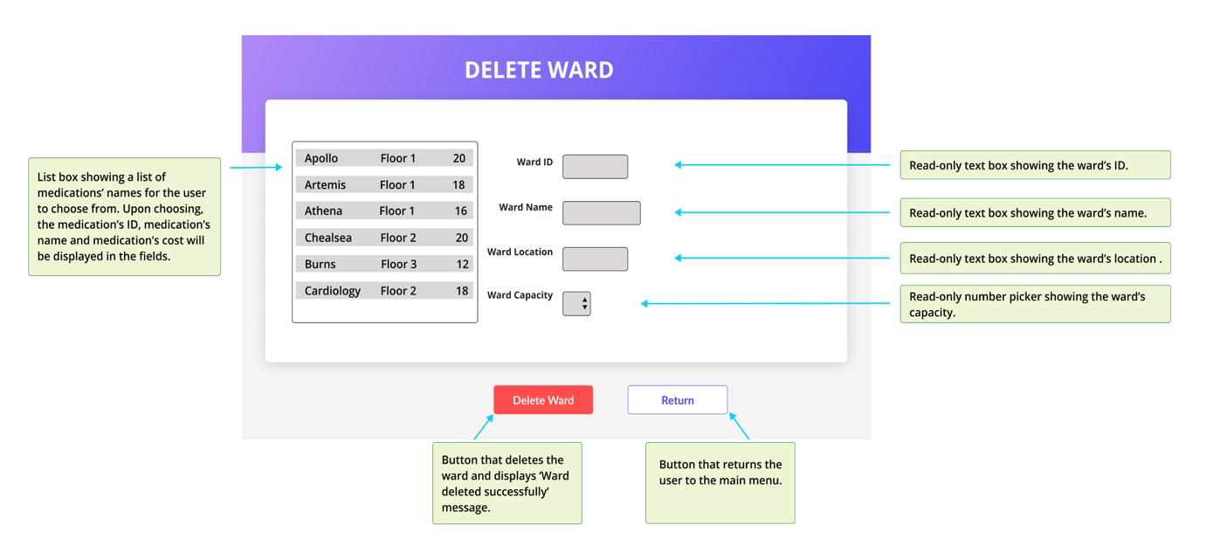

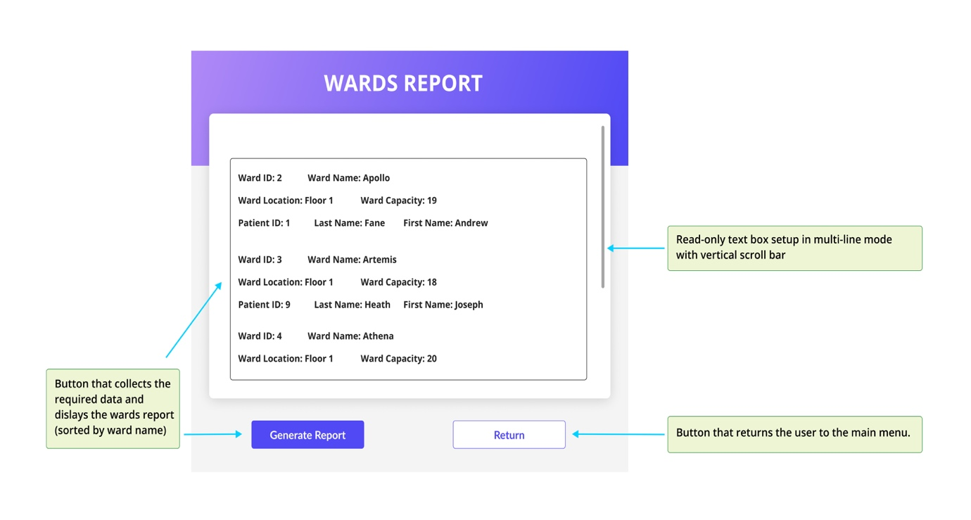

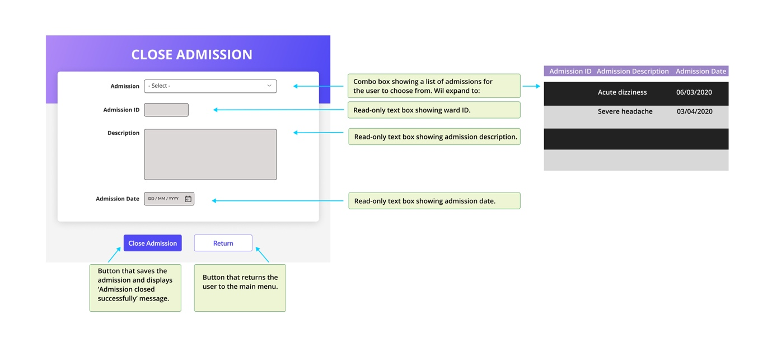

## 

## 8.9 Test Plan

For the purpose of Quality Assurance, two types of tests were designed. One, the use-case test plans were drafted to ensure the requirements of the project are met. Design-level use cases were studied meticulously and for each use case, a test plan was designed to test the typical course of events and each alternative courses of actions. These were recorded on spreadsheets.

The second type of test was schema testing where each class with its attributes in the data dictionary was subject to testing according to the validation rules set earlier for the project.

Both tests were later administered to the application checking for functionality of forms, fields, list boxes, buttons and required fields. The results of the tests were recorded on the spread sheets (see appendix).

# 9. Project Training

## 9.1 End User Background and Training Objectives

In order to demonstrate how the final product works, a 6-minute video was produced showing the functionality of forms. Each form was shown and voice-over explanations on the video provided clear instructions for ultimate users of the forms, who are going to be assistant administrator, facilities administrator and pharmacy administrator in Saint Albert Hospital in Auckland.

The video shows how the forms are initiated, how the data is entered, what information is present on each form and also the message boxes which provide information for the users. It also reviews what information the ward report form displays.

## 9.2 Training Materials

For the creation of the training videos, this software was used:

* QuickTime Player (MACOS) 2021

## 9.3 Training Deliverables

* Video enclosed

## 9.4 Evaluation

The instructions are presented in a very clear manner and it is hoped that the user can have a thorough understanding of the application and its functionality. The video also shows how the validation rules and limits are applied if required fields are not filled in. The video starts with indication of what the video is about and ends with a summary and information on how the user can contact the project manager.

# 10. Conclusion & Lessons Learned

This project scope was relatively large for the amount of time allocated. Within the limited time, a fine product was created from scratch and its functionality tested. The forms perform tasks as set by the client’s requirement* and with relative ease. The forms seem to be easy to use and the information they display are clear. It is hoped that the product can replace the old system and provide faster and easier method of accessing and storing information.

After close examinations of the requirements overall Class and ERD diagrams were sketched to investigate the required classes and attributes and their relationships. Activity diagrams for each of the 8 use cases were also drawn to guide steps to be followed in each use case to ensure functionality of the final product. These were to lead the decisions made for the development of the software.

Design use case narratives (descriptors) would be the ultimate user stories to be followed meticulously in the creation of the final product and to guide the stages of coding and testing. They went through multiple modifications and in consultation with the project sponsors. Then 8 user interface wireframes were created to guide the design of the main menu, forms, buttons, colours and sizes.

Data dictionary was created with validation rules and then database was designed with the required tables and fields for the recording of the data from the hospital. All 10 classes, earlier decided on, were inserted with sample data to demonstrate the functionality of the final product.

For the purposes of the quality assurance and to prevent errors, some test case plans were drafted for each use case.

The implementation stage commenced finally with coding the program using Visual Studio C# to create windows forms. The progress and queries were communicated with the project sponsors during meetings and in close consideration of the design use case narratives. Narratives were constantly modified to account for the functionality and coding limitation of the application. The test case plans were referred to on various occasions to guide the development process of the application and to ensure quality of the product which would ultimately pass tests and meet client’s expectations.

Subsequent tests were carried out and changes followed, if needed, to address the defects and bugs. Test reports were written.

This project was accomplished by improving the knowledge of analysing stakeholders’ requirements and designing what is expected, having in mind the expectation of the robust product which meets standards. From the analysis stage to design and deployment, 180 hours of work was committed for the completion of this project and detailed knowledge of each component of the project was favourably acquired.

A more in depth knowledge of the programming language used could facilitate better construction of the application. The limitations led to enormous amount of time exhausted on the coding stage. As an example the use of list box instead of combo box, which was the preferred feature, was adopted due to this limitation in the use of the language. Also, the form “Close Admission” could not be completed. The use of another programming language would have, possibly, created a better product.

*During the final stages of the project and especially while performing use case tests, some oddity in forms functionality were observed from time to time. Some of the design and code changes had not been administered for a period of time and this inhibited the development of a better product and consumed additional time.

These were revealed, when the change to the forms’ colours and buttons would not be applied and were suddenly shown after a week. This is when it was realised that some changes in codes were also not applied and shown. One example of this oddity was observed on the update forms. When the user decides to update another medication/ward, the previous updated item disappears from the list box. It exits, however, in the database and upon restarting the application. These oddities were not recorded on the test plans due to sporadic occurrence.

It is believed that some of this behaviour could be due to the use of Virtual Machine, as experienced also in a previous project. The access to other device was also limited due to Covid-19 restrictions and lock down.

# References

Caspio. (2020). Build Hospital Management Solutions Without Coding. Retrieved from <https://go.caspio.com/hospital-management-071620?r=https://www.capterra.co.nz/x/45458/caspio?category=11959&clickout_type=landing_page&clickout_placement=category-show-landing_page&s=1201&d=790>

JavaTPoint. (2021). Agile Model. Retrieved from

<https://www.javatpoint.com/software-engineering-agile-model>

Guru99. (2021a). V-Model in Software Testing. Retrieved from

<https://www.guru99.com/v-model-software-testing.html>

Guru99. (2021b). Agile Methodology: What is Agile Software Development Model? Retrieved from <https://www.guru99.com/agile-scrum-extreme-testing.html>

Guru99. (2021c). SDLC: Phases & Models of Software Development Life Cycle. Retrieved from <https://www.guru99.com/software-development-life-cycle-tutorial.html>

NextGenHMS. (2021). NextGen Healthcare. Retrieved from <https://www.nextgen.com/about-us>

SoftClinic (2021). Capterra. Retrieved from <https://www.capterra.co.nz/software/130500/softclinic>

Tutorialspoint. (2021a). SDLC-Waterfall Model. Retrieved from <https://www.tutorialspoint.com/sdlc/sdlc_waterfall_model.htm>

Tutorialspoint. (2021b). SDLC - Agile Model. Retrieved from <https://www.tutorialspoint.com/sdlc/sdlc_agile_model.htm>

# Appendices

**6.2 GANTT Chart**



**6.4 Project Meetings**













**6.5 Project Status Report**

**Project Status Report 1**

**Period ending – 22/10/2021**

|  |  |  |  |
| --- | --- | --- | --- |
| **Project Name** | Saint Albert | **Project Sponsor** | Simon Dacey/Lei song |
| **Project Number** | 2 | **Project Manager** | Mohsen M Ansari |
| **Project Phase** | Planning/Analysis/Design | **Date** | 25/10/2021 |

|  |  |
| --- | --- |
| **Project Description** | Desktop application to manage a hospital operations |

**Project Status Summary: ☺  ☺↑ 😐 😐↑ 😐↓  ☹  ☹↓**

|  |  |  |  |  |  |  |  |  |  |
| --- | --- | --- | --- | --- | --- | --- | --- | --- | --- |
| **Project Status** | **Overall** | **Scope** | **Schedule** | **Budget** | **Resource** | **Commercial** | **Issues** | **Risks** | **Business**  **Engagement** |
| (Select appropriate face for each box) | **☺** | **☺** | **☺** | **N/A** | **☺** | **N/A** | **😐** | **☺** | **N/A** |

Further status description only required where summary is **😐** or **☹**.

|  |  |
| --- | --- |
| **Overall** |  |
| **Scope** |  |
| **Schedule** |  |
| **Budget** | **N/A** |
| **Resource** |  |
| **Commercial** | **N/A** |
| **Issues** | Some software needed for this project does not run on MAC operating system and should be run on VM, with its limitations. One big issue this causes is the speed of delivery. |
| **Risks** |  |
| **Business Engagement** | **N/A** |

**Project Progress Summary**

|  |  |  |  |  |  |
| --- | --- | --- | --- | --- | --- |
| **Milestones** | **Delivery dates** | | | **On track?** | **Current Status update** |
| **Actual Start** | **Baseline Finish** | **Exp/Actual Finish** |  |  |
| **Gantt Chart** | **20/09/2021** | **23/09/2021** |  | **Yes** | **Completed** |
| **Technology Review** | **24/09/2021** | **31/10/2021** | **29/10/21** | **No** | **Discussed with project sponsor to do Tech Review later in the stages of the project as more information will be available about the project.** |
| **Analysis Material** | **27/09/2021** | **01/10/2021** | **06/10/2021** | **No** | **Completed-It is now on track-Lots of tweaking occurred while diagrams were being drawn** |
| **Design Material** | **18/10/2021** | **29/10/2021** | **29/10/2021** | **Yes** | **Completed** |

|  |  |
| --- | --- |
| **Key achievements this period** | **Project commenced. Gantt chart completed. Requirement analysis completed.** |

|  |  |
| --- | --- |
| **Achievements planned for this period but not achieved** | **Technology Review to be completed by 29/10/2021.** |

|  |  |
| --- | --- |
| **Planned for next period** | **Completion of Project Design material for the second week and commencement of coding stage.** |

|  |  |
| --- | --- |
| **Action Items for Sponsor** |  |

**Issues (High)**

|  |  |  |  |  |  |  |
| --- | --- | --- | --- | --- | --- | --- |
| **Nr.** | **Date Raised** | **Description** | **Priority/**  **Impact** | **Owner** | **Date for Action** | **Resolution Action** |
|  |  |  |  |  |  |  |

**Risks (Extreme & High)**

|  |  |  |  |  |  |  |
| --- | --- | --- | --- | --- | --- | --- |
| **Nr.** | **Date Raised** | **Description** | **Overall Rating** | **Owner** | **Date for Action** | **Mitigation / Treatment** |
|  |  |  |  |  |  |  |

**Project Status Report 2**

**Period ending – 05/11/2021**

|  |  |  |  |
| --- | --- | --- | --- |
| **Project Name** | Saint Albert | **Project Sponsor** | Simon Dacey/Lei song |
| **Project Number** | 2 | **Project Manager** | Mohsen M Ansari |
| **Project Phase** | Design | **Date** | 05/11/2021 |

|  |  |
| --- | --- |
| **Project Description** | Desktop application to manage a hospital’s operations |

**Project Status Summary: ☺  ☺↑ 😐 😐↑ 😐↓  ☹  ☹↓**

|  |  |  |  |  |  |  |  |  |  |
| --- | --- | --- | --- | --- | --- | --- | --- | --- | --- |
| **Project Status** | **Overall** | **Scope** | **Schedule** | **Budget** | **Resource** | **Commercial** | **Issues** | **Risks** | **Business**  **Engagement** |
| (Select appropriate face for each box) | **☺** | **☺** | **☺** | **N/A** | **☺** | **N/A** | **😐** | **☺** | **N/A** |

Further status description only required where summary is **😐** or **☹**.

|  |  |
| --- | --- |
| **Overall** |  |
| **Scope** |  |
| **Schedule** |  |
| **Budget** | **N/A** |
| **Resource** |  |
| **Commercial** | **N/A** |
| **Issues** | Some software needed for this project does not run on MAC operating system and should be run on VM, with its limitations. This affects speed of delivery. |
| **Risks** |  |
| **Business Engagement** | **N/A** |

**Project Progress Summary**

|  |  |  |  |  |  |
| --- | --- | --- | --- | --- | --- |
| **Milestones** | **Delivery dates** | | | **On track?** | **Current Status update** |
| **Actual Start** | **Baseline Finish** | **Exp/Actual Finish** |  |  |
| **Gantt Chart** | **20/09/2021** | **23/09/2021** | **23/09/2021** | **Yes** | **Completed** |
| **Technology Review** | **24/09/2021** | **31/10/2021** | **29/10/21** | **Yes** | **Completed** |
| **Analysis Material** | **27/09/2021** | **01/10/2021** | **06/10/2021** | **Yes** | **Completed** |
| **Design Material** | **18/10/2021** | **29/10/2021** | **29/10/2021** | **Yes** | **Completed** |
| **Design & Development** | **01/11/2021** | **12/11/2021** | **12/11/2021** | **Yes** | **In Progress- 6 forms completed** |

|  |  |
| --- | --- |
| **Key achievements this period** | **Technology review is completed. Test cases are completed. Development is at a good progress with 6 forms completed.** |

|  |  |
| --- | --- |
| **Achievements planned for this period but not achieved** |  |

|  |  |
| --- | --- |
| **Planned for next period** | **Completion of Project Development material by 12/11/2021 week.** |

|  |  |
| --- | --- |
| **Action Items for Sponsor** |  |

**Issues (High)**

|  |  |  |  |  |  |  |
| --- | --- | --- | --- | --- | --- | --- |
| **Nr.** | **Date Raised** | **Description** | **Priority/**  **Impact** | **Owner** | **Date for Action** | **Resolution Action** |
|  |  |  |  |  |  |  |

**Risks (Extreme & High)**

|  |  |  |  |  |  |  |
| --- | --- | --- | --- | --- | --- | --- |
| **Nr.** | **Date Raised** | **Description** | **Overall Rating** | **Owner** | **Date for Action** | **Mitigation / Treatment** |
|  |  |  |  |  |  |  |

**Project Status Report 3**

**Period ending – 19/11/2021**

|  |  |  |  |
| --- | --- | --- | --- |
| **Project Name** | Saint Albert | **Project Sponsor** | Simon Dacey/Lei song |
| **Project Number** | 2 | **Project Manager** | Mohsen M Ansari |
| **Project Phase** | Design | **Date** | 22/11/2021 |

|  |  |
| --- | --- |
| **Project Description** | Desktop application to manage a hospital’s operations |

**Project Status Summary: ☺  ☺↑ 😐 😐↑ 😐↓  ☹  ☹↓**

|  |  |  |  |  |  |  |  |  |  |
| --- | --- | --- | --- | --- | --- | --- | --- | --- | --- |
| **Project Status** | **Overall** | **Scope** | **Schedule** | **Budget** | **Resource** | **Commercial** | **Issues** | **Risks** | **Business**  **Engagement** |
| (Select appropriate face for each box) | **☺** | **☺** | **☺** | **N/A** | **☺** | **N/A** | **😐** | **☺** | **N/A** |

Further status description only required where summary is **😐** or **☹**.

|  |  |
| --- | --- |
| **Overall** |  |
| **Scope** |  |
| **Schedule** |  |
| **Budget** | **N/A** |
| **Resource** |  |
| **Commercial** | **N/A** |
| **Issues** | Some software needed for this project does not run on MAC operating system and should be run on VM, with its limitations. This affects speed of delivery. |
| **Risks** |  |
| **Business Engagement** | **N/A** |

**Project Progress Summary**

|  |  |  |  |  |  |
| --- | --- | --- | --- | --- | --- |
| **Milestones** | **Delivery dates** | | | **On track?** | **Current Status update** |
| **Actual Start** | **Baseline Finish** | **Exp/Actual Finish** |  |  |
| **Gantt Chart** | **20/09/2021** | **23/09/2021** |  | **Yes** | **Completed** |
| **Technology Review** | **24/09/2021** | **31/10/2021** | **29/10/21** | **Yes** | **Completed** |
| **Analysis Material** | **27/09/2021** | **01/10/2021** | **06/10/2021** | **Yes** | **Completed** |
| **Design Material** | **18/10/2021** | **29/10/2021** | **29/10/2021** | **Yes** | **Completed** |
| **Design & Development** | **01/11/2021** | **12/11/2021** | **12/11/2021** | **Yes** | **Completed** |
| **Tests** | **11/11/2021** | **11/11/2021** | **11/11/2021** | **Yes** | **Completed** |

|  |  |
| --- | --- |
| **Key achievements this period** | **Tests are completed. Report form is developed. Technical Report completed.** |

|  |  |
| --- | --- |
| **Achievements planned for this period but not achieved** |  |

|  |  |
| --- | --- |
| **Planned for next period** | **Create end user training material. Complete project’s technical report.** |

|  |  |
| --- | --- |
| **Action Items for Sponsor** |  |

**Issues (High)**

|  |  |  |  |  |  |  |
| --- | --- | --- | --- | --- | --- | --- |
| **Nr.** | **Date Raised** | **Description** | **Priority/**  **Impact** | **Owner** | **Date for Action** | **Resolution Action** |
|  |  |  |  |  |  |  |

**Risks (Extreme & High)**

|  |  |  |  |  |  |  |
| --- | --- | --- | --- | --- | --- | --- |
| **Nr.** | **Date Raised** | **Description** | **Overall Rating** | **Owner** | **Date for Action** | **Mitigation / Treatment** |
|  |  |  |  |  |  |  |

**6.6 Project Risks**

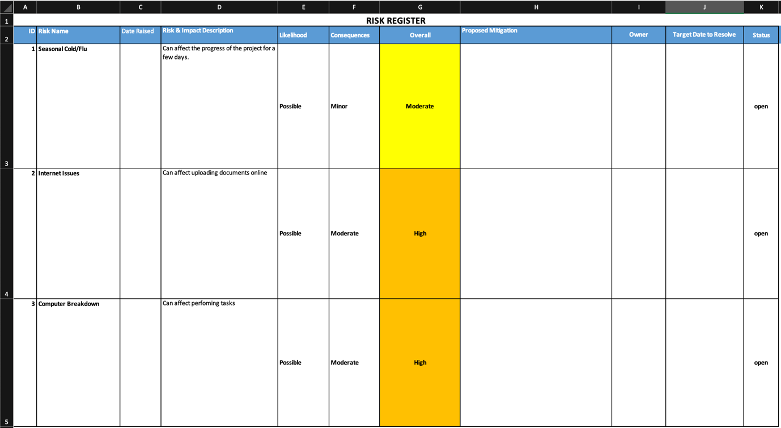

**8.9 Test Plans**

**Use case Tests**

**Use Case 16 – Add Medication**



**Use Case 17 – Update Medication**



**Use Case 18 – Delete Medication**



**Use Case 22 – Add Ward**



**Use Case 23 – Update Ward**



**Use Case 24 – Delete Ward**



**Use Case 25 – Produce Wards Report**



**Use Case 26 – Close Admission**



**Schema Tests**

**1.Ward Table**



**2. Patient Table**



**3. Doctor Table**



**4. Research Topic**



**5. Medication Table**



**6. Admission Table**



**7. Allocation Table**



**8. Prescription Table**



**9. Research Project Table**



**10. Payment Table**



**9.3 Training Deliverables**

https://unitecnz-my.sharepoint.com/:v:/r/personal/moalem01_myunitec_ac_nz/Documents/Tranining%20Video-Matt%20.mp4?csf=1&web=1&e=HKL5aE

**Presentation:**

https://unitecnz-my.sharepoint.com/:p:/r/personal/moalem01_myunitec_ac_nz/Documents/Presentation%20(1).pptx?d=w8d005849f81f4b169c3ef168675afb69&csf=1&web=1&e=x3yISM